**Greenfield Primary Academy**

**Year 5**

**Spring 2 Term Learning Letter 2022**

**In Math we are studying Fractions.**

* **Equivalent fractions**
* **Improper and mixed fractions**
* **Comparing and ordering fractions**
* **Number sequences**
* **Adding and subtracting fractions**
* **Fractions of amounts.**

**In English we are studying Shakespeare’s Twelfth Night**

**Our writing focuses will be:**

* **Diary entries**
* **Setting descriptions**
* **Retelling a story**
* **Love poems/speech**

**Our Learning Theme is …**

**France**

**Rivers**



**In RE we are studying: What would Jesus do? Can we live by the values of Jesus in the 21st Century?**

* **Mission Statement**
* **How Jesus taught love**
* **Forgiveness**
* **Justice and Fairness.**

**In Art we are studying Landscapes.**

* **Comparing artists**
* **Looking at perspectives.**
* **Recreating images.**
* **Design/paint own landscape**

**In Science we are studying properties and material.**

* **Comparing materials**
* **Thermal conductors and insulators**
* **Electrical conductors**

**In Geography we are studying Rivers.**

* **Water Cycle**
* **Where does water come from?**
* **River System**
* **How rivers change shape and why?**
* **Why we use rivers**
* **Comparing rivers.**

**In RHE/ PSHE we are studying the effects of drugs, alcohol and Tobacco.**

* **Understand drugs and the effects.**
* **Effects of smoking**
* **Effects of Alcohol**

 In Year 5 there is a certain expectation when it comes to Home Learning. Please see this outlined below:

**Individual Reading Books**

All children must read a few pages each night at home and write a comment in their reading diary.

**MyOn**

Children are expected to complete MyOn reading everyday with books of their choice online.

**TT Rockstars**

Children will be set 25mins (5 mins daily) of TTRockstars to practise their times tables.

**SumDog**

Children will be set a task on SumDog where they have 50 questions to answer based on their learning in class that week.

**Spellings**

Children will have spelling practise to complete based on those words they found tricky in the lesson that week and a spelling quiz on Purple Mash.

**Home Learning is set on a Friday and is expected to be completed by Tuesday morning.**

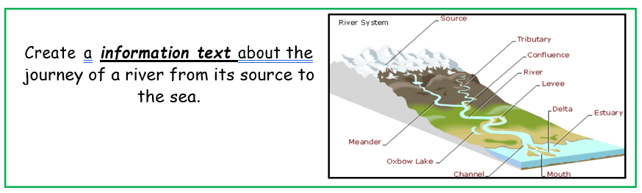

**Year 5 Half Term Learning Project**

**Year 5 Weekly Home Learning Tasks**