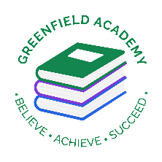**Greenfield Primary Academy**

**Year 4**

**Summer Term 1 Learning Letter 2023**

**In English we are learning to …**

**Write in different ways:** We will be looking at writing for a variety of purposes through the use of the texts The Egyptian Cinderella and Awesome Egyptians. We will be writing stories fantasy stories, character and setting descriptions, a formal letter to an author and calligrams.

**Read more fluently:** We will continue with our comprehension lessons three days a week, building on the skills we have been learning. We will continue to read in class with your child and they will also use MyOn – our online reading program.

**Understand Grammar:** We will continue to gather new vocabulary and will be using nouns, verbs, adjectives and prepositions. We will continue to use a range of connectives and adverbials, use inverted comma’s for speech, verb inflections (was/were) and write commands, statements, exclamations and questions.

Write questions, commands, exclamations and statements

Pronouns and nouns (choices in sentences)

**In Maths we are learning to …**

**Decimals**. We have done a lot of work on Decimals in the Spring term and will continue with this for the first few weeks of term. We will be, ordering, comparing and rounding decimals.

**Money:** We will be looking at pounds and pence, ordering money, adding and subtracting money and giving change. **It will be handy for the children to start calculating when they go out shopping.**

**Time:** We will be learning to tell the time on an analogue and digital clock to the minute and 5 minutes and am/pm

**Times table practice:** The year 4 National MTC (Multiplication Times Check) is in June, so please continue to learn times and division facts.

**Every child needs to continue with TTRockstars and Sumdog for ten minutes every night.**

**In RE we are learning…**

**about deciding what is right and wrong? And will study this through Christianity, Judaism and Sikhism**

* give examples of rules for living from religions and suggest ways in which they might help with difficult decisions.
* make connections between stories of temptation and why people can find it difficult to be good.
* give examples of ways some inspirational people have been guided by their religion. discuss their own and others’ ideas about how people decide right and wrong.

**In Design Technology we are learning how to:**

* Design a project that is strong and aesthetically pleasing
* Make a product using suitable materials that meets the design brief
* Look at our work and improve on our designs as we make it.
* Evaluate whether our work has met the design brief and talk about how we can improve next time.

**Our Learning Theme is …**

**The Ancient Egyptians**

**In Science we are learning …**

**Living things and their habitats**

* recognise that living things can be grouped in a variety of ways
* explore and use classification keys to help group, identify and name a variety of living things in their local and wider environment
* recognise that environments can change and that this can sometimes pose dangers to living things.

**Animals including humans**

* construct and interpret a variety of food chains, identifying producers, predators and prey.

**In History we are learning to …**

* Place some historical periods in a chronological framework.
* Use historic terms related to the period of study.
* Use sources of information in ways that go beyond simple observations to answer questions about the past.
* Use a variety of sources to find out about aspects of life in the past.
* Communicate learning in an organised and structured way, using appropriate terminology.

This will all be taught by studying the Ancient Egyptians and how they have influenced our lives today.

**In RHE/ PSHE we are learning about …**

In Year 4, the children will look at how their body has or will begin to change soon and the different emotions that may come along with this. As they look at changes while they grow, they will also look at the importance of good quality sleep for good health and re-visit dental health and why they should continue with regular brushing, flossing and visits to the dentist especially as they lose their teeth and get their final set that will have to last all their adult life.

Any questions? Please ask us at the door when you collect your child.

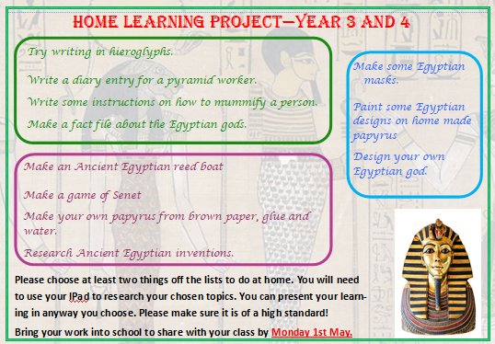

**The Ancient Egyptians**

Your child’s Home Learning challenge is to research the Ancient Egyptians using their iPad. They need to choose 2 things to make from the suggestions on the sheet

Don’t forget to label your work and write some interesting facts to share with your class after the holidays.

All work must be presented to a high quality.

**Please bring them back on Monday 1st May**

**Year 4 Half Term Learning Project**

**Year 4 Weekly Home Learning Tasks**

**READING**

Please share your child’s reading book with them, as **10-15 minutes** of reading **every day** at home can make a lot of difference to your child's reading ability.

Your child MUST bring their book bag into school **every day** so an adult can read with them on their reading day, and any extra days if there is an opportunity.

Each child will have a reading book, and an extra book from the class library.

Every child will have an online MyOn account where they can read books and answer questions. This is in addition to their daily reading book task.

**MATHS**

Every child has a TTRockstars and Sumdog account. They can use these to practise their number bonds and times tables facts online. 10 minutes **every day** will mean they will be ready for their times tables test in June, and will make them much quicker at working things out in class.

**PURPLE MASH**

Sometimes work will be set on Purple Mash. They log on to their account and complete their tasks. When they log on, there is a bell at the top of the screen. When they click on this, it will show them all the tasks they need to complete for that week.

Tasks are allocated on a Friday and have to be completed by the following Tuesday.