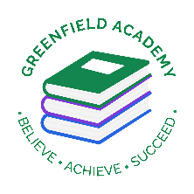**Greenfield Primary Academy**

**Year 5**

**Summer 1 Term Learning Letter 2022**

**In Math we are studying:**

* **Fractions of number**
* **Adding decimals**
* **Subtracting decimals**
* **Multiplying by 10,100 and 1000**
* **Dividing by 10,100 and 1000**

**In English we are studying Grimms’ Tales**

**We will be focusing on Little Red Riding Hood.**

* **Setting descriptions**
* **Character profiles**
* **Persuasive letters**
* **Newspaper reports**
* **Own story**

**Our Learning Theme is …**

**The Victorians**

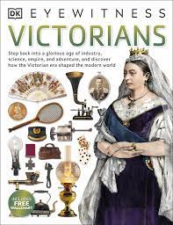

**In RE we are studying: If god is everywhere, why go to a place of worship?**

* **Churches**
* **Synagogues**
* **Hindu Temples**
* **Create our own place of worship.**

**In D.T we will learn how to make scones.**

* **Taste different scones**
* **Learn the technique for kneading.**
* **Create own recipes.**
* **Make and evaluate Scones.**

**In Science we are studying Living things.**

* **Life cycles of mammals, amphibians, insects and birds.**
* **Life process/reproduction of animals and plants.**
* **Describe changes in humans over time.**

**In History we are studying The Victorians.**

* **Victorians and British timeline**
* **Queen Victoria**
* **Victorian schooling.**
* **Children in Victorian times**

**In RHE/ PSHE we will be completing Apple Module 4 – Solving Problems and how to stay safe online.**

* **Effects of online bullying – mentally and effect on others.**
* **Know how to get help**
* **Benefits of rationing time online.**

 In Year 5 there is a certain expectation when it comes to Home Learning. Please see this outlined below:

**Individual Reading Books**

All children must read a few pages each night at home and write a comment in their reading diary.

**MyOn**

Children are expected to complete MyOn reading everyday with books of their choice online.

**TT Rockstars**

Children will be set 25mins (5 mins daily) of TTRockstars to practise their times tables.

**SumDog**

Children will be set a task on SumDog where they have 50 questions to answer based on their learning in class that week.

**Spellings**

Children will have spelling practise to complete based on those words they found tricky in the lesson that week and a spelling quiz on Purple Mash.

**Home Learning is set on a Friday and is expected to be completed by Tuesday morning.**

Your task is to research an **invention from Victorian times** and the **person who invented it.** Then create a fact file about it and its inventor. You can present the information in this fact file however you wish. Be as creative as possible!

You could include information such as:

* Who was it that invented the invention?
* What was their occupation, what was their family life like? What was their childhood like?
* What’s does the invention do? What does it look like?
* How did the inventor come up with their idea?
* What makes their invention so special?
* How does their invention effect modern life?

**Year 5 Half Term Learning Project**

**Year 5 Weekly Home Learning Tasks**