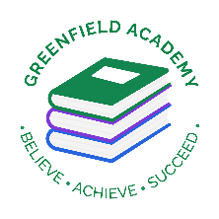**Greenfield Primary Academy**

**Year 2**

**Summer Term: 2 Learning Letter 2023**

**In English this half term all our texts have been carefully chosen to fit with our topic. Our first story is called ‘There’s no Dragon in this Story’. First, we will learn to describe ‘Dragon’ and then move on to retelling and innovating the story to create our own.**

**We will then read a story called ‘Good Knight, Bad Knight’. We will consider how to be a good knight and write explanations to teach others these skills. We will finish by writing a setting description based on the story ‘The Kiss that Missed’.**

**In Maths we will be revising all we have learnt this year plugging any gaps in our knowledge.**

**We will revisit fractions and money so that we can confidently divide numbers into quarters and make amounts in different ways.**

**We will learn all about units of measurement and how to measure length, weight and capacity.**

**Our Learning Theme is …**

**‘Castles’**

**In RE we are learning all about how and why we should care for others in the world. We will think about we can turn negative situations into positive ones and consider what we learn from the story of ‘The Good Samaritan’. We will compare how different religions care for one another linked to their beliefs.**

**In DT we are learning how to design and make a castle.**

**We will study how to make our structure strong, realistic and attractive.**

**We will study the parts of castles and how to make a drawbridge that opens and closes.**

**In Science we will learn all about Materials and their uses and properties.**

**We will work in teams to consider how different objects made from different materials can be grouped and classified, test materials to see which one would be best for different jobs and uses and consider how materials can be changed by squashing, squeezing or stretching.**

**In History we will be learning all about ‘Castles’. We will visit Skipton Castle for a stunning start to our topic and research the parts and structures of a castle.**

**We will consider why castles were cleverly designed for protection and defense in battles and think about what life was like for people who lived in them.**

**In RHE/ PSHE we will be understanding the emotions we feel when we experience grief and loss. The children will hear a Zippy story where a child loses his pet stick insect. We will explore the character’s emotions and consider what he can do to feel better in the situation. We will approach the subject with respect as we share our own experiences and learn how to help each other through times of sadness.**

**READING**

Please share your child’s reading book with them, as **10-15 minutes** of reading **every day** at home can make a lot of difference to your child's reading ability.

Your child MUST bring their book bag into school **every day** so an adult can read with them on their reading day, and any extra days if there is an opportunity.

Please complete your reading book and comprehension questions on Phonics Bug each week which can be found in your Phonics Bug library.

**MATHS**

**Measure and compare lengths, weights and capacities in the home. Revise 2,5,10 times tables and recognize coins and notes. Learn the 3 x table.**

As detailed in our Home Learning Project letter please research and find out the names of each part of a castle and what job it did.

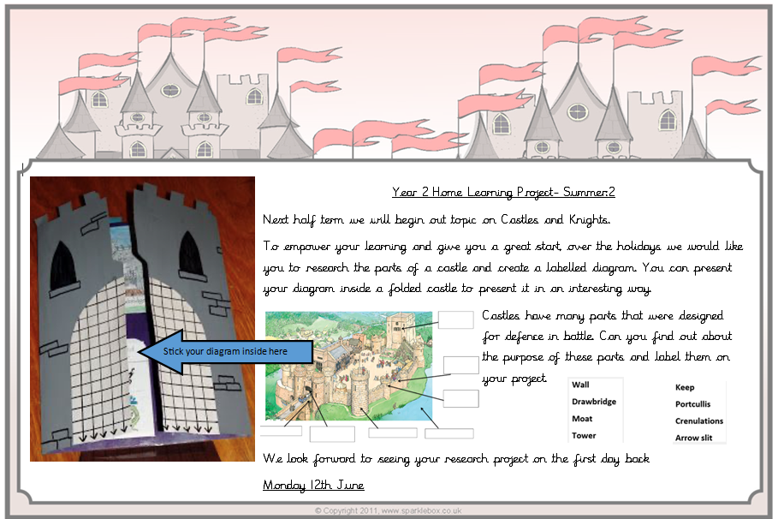

**Year 2 Half Term Learning Project**

**Year 2 Weekly Home Learning Tasks**