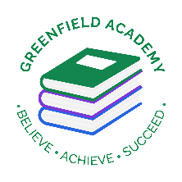**Greenfield Primary Academy**

**Year 4**

**Summer Term 2 Learning Letter 2023**

**In Maths we are learning about…**

**Time:** Children will begin by recapping telling the time from year 3 before moving on to new learning focused around converting between different units of time. This will include telling the time to 5 mins, then every mins, looking at 12- and 24-hour time and word problems.

**Statistics:** We will be looking at data and interpreting charts and graphs.

**Shape:** We will be looking at properties of shapes, turns and angles and lines of symmetry.

**Geometry:** We will be looking at position and direction.

**Every child needs to continue with TTRockstars and Sumdog every night. The Year 4 Multiplication check is straight after the holiday so please continue to practise every day!**

**In English we are learning to …**

**Write in different ways:** We will learn about reading and writing myths and legends, mystery stories and explanation texts. We will use the story ‘Sir Charlie Stinky Socks and the Mummy’s Gold’ to write setting and character descriptions, as well as our own mystery stories. We will also look at texts about Gods and Pharaohs and write explanations.

**Read more fluently:** We will continue with comprehension lessons three times a week. We will be learning to answer literal, deductive and inference questions. Your child has a reading book and will also have access to MyOn – our online reading program. We try to read with them at least once a week – we can’t guarantee which day it will be.

**Understand Grammar:** We will consolidate our knowledge of Fronted adverbials, direct and indirect speech and the use of passive voice.

**In RE we are learning…Why do some people think life is a journey?**

• Suggest why some people see life as a journey and identify some of the key milestones on this journey

• Describe what happens in Christian, Jewish, and/or Hindu ceremonies of commitment and say what these rituals mean

• Suggest reasons why marking the milestones of life are important to Christians, Hindus and/or Jewish people

• Link up some questions and answers about how believers show commitment.

**Our Learning Theme is …**

**The River Nile**

**In Art…we will be learning to print**

* We will research block printing
* Experiment with sculpting clay to make our printing blocks
* Research and experiment printing in the style of famous artists.
* Print on different materials using blocks of colour
* Use a range of printing techniques to create an Andy Warhol style print.

**In Science we are learning that …**

Sound -

* Know how sound is made.
* Know how sound travels from a source to our ears.
* Know the correlation between pitch and the object producing a sound.
* Know the correlation between the volume of a sound and the strength of vibration that produced it.
* Know what happens to a sound as it travels away from its source

**In Geography we are learning to …**

* understand the historical and geographical importance of the River Nile.
* use key vocabulary to describe the features of the river Nile.
* understand vital importance of the Nile for farmers.
* understand the role the River Nile plays in the transport of goods.
* compare the River Nile to a local river.
* understand how humans impacted the River Nile.

**In RHE/ PSHE we are learning about … First Aid**

We will be learning how to make an emergency call, how to keep safe in an emergency and some basic First Aid which again is a very important life skill for the children to have.

At the end of Summer 2, they will also look at their aspirations and base this around transition to their next year group.

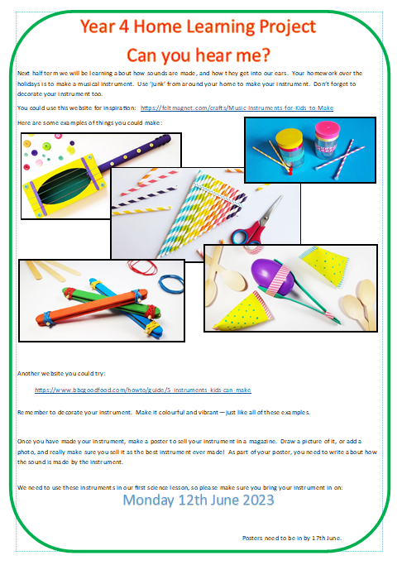

Our Learning Project Term is focussed on our Science topic which is Sound.

There a few tasks to complete and the deadline for this is first week back after half term which is **Monday 17th June.**

**READING**

Please share your child’s reading book with them, as **10-15 minutes** of reading **every day** at home can make a lot of difference to your child's reading ability.

Your child MUST bring their book bag into school **every day** so an adult can read with them on their reading day, and any extra days if there is an opportunity.

Each child will have a reading book, and an extra book from the class library.

Every child will have an online Myon account where they can read books and answer questions. This is in addition to their daily reading book task.

**MATHS**

Every child has a TTRockstars and Sumdog account. They can use these to practise their times tables facts online. 10 minutes **every day** will mean that they are ready for their times tables test next term.

Weekly home learning for maths will be set on Sumdog every Friday and the children have until Tuesday to complete their tasks. The learning will support the lessons that have taken place that week.

**Year 4 Half Term Home Learning Project**

**Year 4 Weekly Home Learning Tasks**