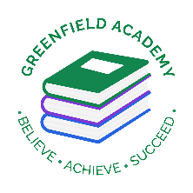**Greenfield Primary Academy**

**Year 6**

**Autumn Term 2 Learning Letter 2023**

**In English we are studying :**

* The Diary of Anne Frank - writing a biography about her and Newspaper reports based on her hiding from the Germans.
* The War Diaries- creating exciting examples of our own.
* Winter Wonderland Poem- creating our own with a focus on senses.

**In Maths we are learning:**

* Fractions – adding, subtracting multiplying and dividing
* Fractions of amounts and ordering and comparing.
* Decimals
* Percentages
* Ratio and Proportion.
* 2D shape
* Roman Numeral and BIDMAS

**Our Learning Theme is …**

**20th Century Britain**

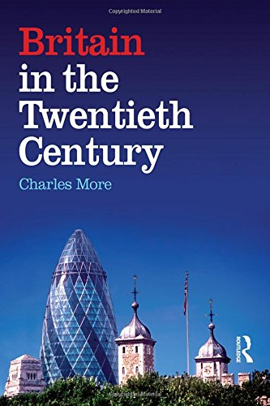

**In RE we are studying:**

* What is Racism and what we learn from different religions?
* What can we learn from the statues in Bristol?
* How Saint Peter learnt God had no favourites?
* What the Golden rule is and why it is found in different religions?

**In D.T we are learning to:**

**Make Anderson Shelter using mod rock.**

* Research Anderson shelters
* Design their own shelters
* Make their own Anderson shelters with chicken wire and mod rock.
* Evaluate their designs.

**In History we are learning about: 20th Century Britain**

* How life changed after WW2
* How inventions were important in the 20th Century
* The importance of Televisions throughout the 20th Century
* Important figures of the 20th Century.

**In Science we are learning about: Electricity**

* Electricity and how components like buzzers, bulbs work and can be controlled.
* Symbols used to draw circuit diagrams.
* Recording measurements and creating graphs.
* Drawing conclusions on the experiments carried out.

**In RHE/ PSHE we are learning how to cope with changes – Apple Module 5**

* Changes being apart of life and how we can adapt to circumstances.
* Coping strategies for difficult situations.
* Different strategies to cope with loss.
* How people can suffer with mental illness.

**Racism Project**

Your task is to create a project about racism. This links to our RE topic for the half term. Your project can be a Power point, poster, leaflet, model etc- be creative!

**Due Date is 8.12.23**

**Questions you may want to consider**

* What is racism?
* Where can you find support?
* What can we do as a community to help stop racism?
* What should you do if you witness racism?

**Year 6 Half Term Learning Project**

In Year 6 there is a certain expectation when it comes to Home Learning. Please see this outlined below:

**MyOn**

Children are expected to complete MyOn reading everyday as well as reading their reading book.

**TT Rockstars**

Children will be set 25mins (5 mins daily) of TTRockstars to practise their times tables.

**SumDog**

Children will be set a task on SumDog where they have 50 questions to answer based on their learning in class that week.

**Grammar and Maths**

Children will be given weekly grammar and maths homework to be completed.

Occasionally there will be a reading comprehension given.

**Home Learning is set on a Friday and is expected to be handed in on Tuesday morning.**

**Year 6 Weekly Home Learning Tasks**