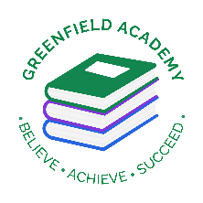**Greenfield Primary Academy**

**Year 6**

**Spring 1 Term Learning Letter 2024**

**In Maths we are learning:**

* **Measurement – Units of measure, mass, length and volume,**
* **Time – Convert 12 and 24hr clock, solving problems, interpret and read timetables.**
* **Length and perimeter – converting miles and kilometers, areas and perimeter.**
* **Angles – straight line, opposite and missing angles.**
* **Constructing shape – Draw 2D shapes.**

**In English we are studying:**

* **The Arrival – Suspense and mystery narrative.**
* **The Island – Diary entries**
* **The Journey – Persuasive writing.**

**We will be studying Choose Love a poem by Nicola3 Davies.**

**In RE we are studying: Is it better to express your beliefs in art and architecture or in charity and generosity?**

* **Why holy buildings matter?**
* **Why works of art matter as a form of devotion?**
* **How generosity and giving to charities help practice their religions.**

**Our Learning Theme is …**

**Refugees**

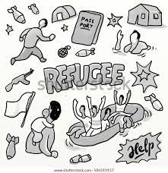

**In Art we are creating a class banner by:**

* **Join fabrics using a variety of different stitches.**
* **Apply decorations using needs and thread – applique**
* **Use mix media collage**
* **Experiment with elements.**

**In Geography we are learning about:**

* **Difference between refugee and migrants and asylum seekers.**
* **Countries affected by war and how people become refugees.**
* **Life of refugees and their struggles.**
* **How everyone has a right to a safe home.**

**In Science we are learning about evolution and adaption.**

* **Living things change over time. Fossils provide information about things that inhabited on Earth.**
* **Living things produce offspring of the same kind but normally are not identical to parents.**
* **How animals and plants are adapted to suit their environment.**

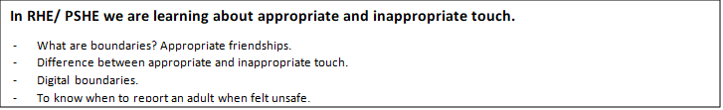

In Science this half term we are learning about Evolution and Charles Darwin.

You project consists of 2 parts:

1. Charles Darwin researched birds and how their beaks adapted to their environment. Read and complete the questions about his research on finches. Then pick 3 of the birds and explain how their beaks have evolved to being the perfect tool to help them with their diets.  You can draw to show the changes of the beaks alongside your explanations.
2. Read through the pages and look at how some people came up with ideas as to how humans could evolve and what changes they could have. On the third page design how, you would like humans to evolve, so that they can adapt to the environment and survive better.

**Project due in on 2nd February**

**Year 6 Half Term Learning Project**

**READING**

Please share your child’s reading book with them, as **10-15 minutes** of reading **every day** at home can make a lot of difference to your child's reading ability.

Your child MUST bring their book bag into school **every day** so an adult can read with them on their reading day, and any extra days if there is an opportunity.

**MATHS**

Children must continue to log in and use TTRockstars and practice their times tables.

**PURPLE MASH**

Weekly home learning task will be set for the children to complete on Purple Mash. Homework will be set on a Friday and will be due in on Tuesday.

**Year 6 Weekly Home Learning Tasks**