**Year 6 Spring 1 Project**

In Science this half term we are learning about Evolution and Charles Darwin.

You project consists of 2 parts:

1. Charles Darwin researched birds and how their beaks adapted to their environment. Read and complete the questions about his research on finches. Then pick 3 of the birds and explain how their beaks have evolved to being the perfect tool to help them with their diets. You can draw to show the changes of the beaks alongside your explanations.
2. Read through the pages and look at how some people came up with ideas as to how humans could evolve and what changes they could have. On the third page design how, you would like humans to evolve, so that they can adapt to the environment and survive better.

**Project due in on 2nd February**

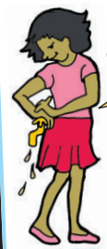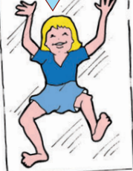 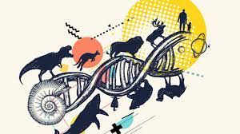

If you need the resources, please come and let me know.