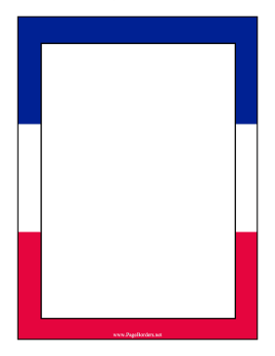

Our Spring 1 project about ...

France

***Our topic this term is about France. We will be looking the physical and human geographical features of France.***

***Your challenge this half term is to create a model of a famous landmark in France.***

***Your model must also come with an information leaflet about the landmark you have made.***

***Below are some examples of what you could create.***

***The deadline for your models and information leaflet is Friday 20th January.***

***Have fun!***

***Miss Begum***

