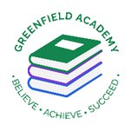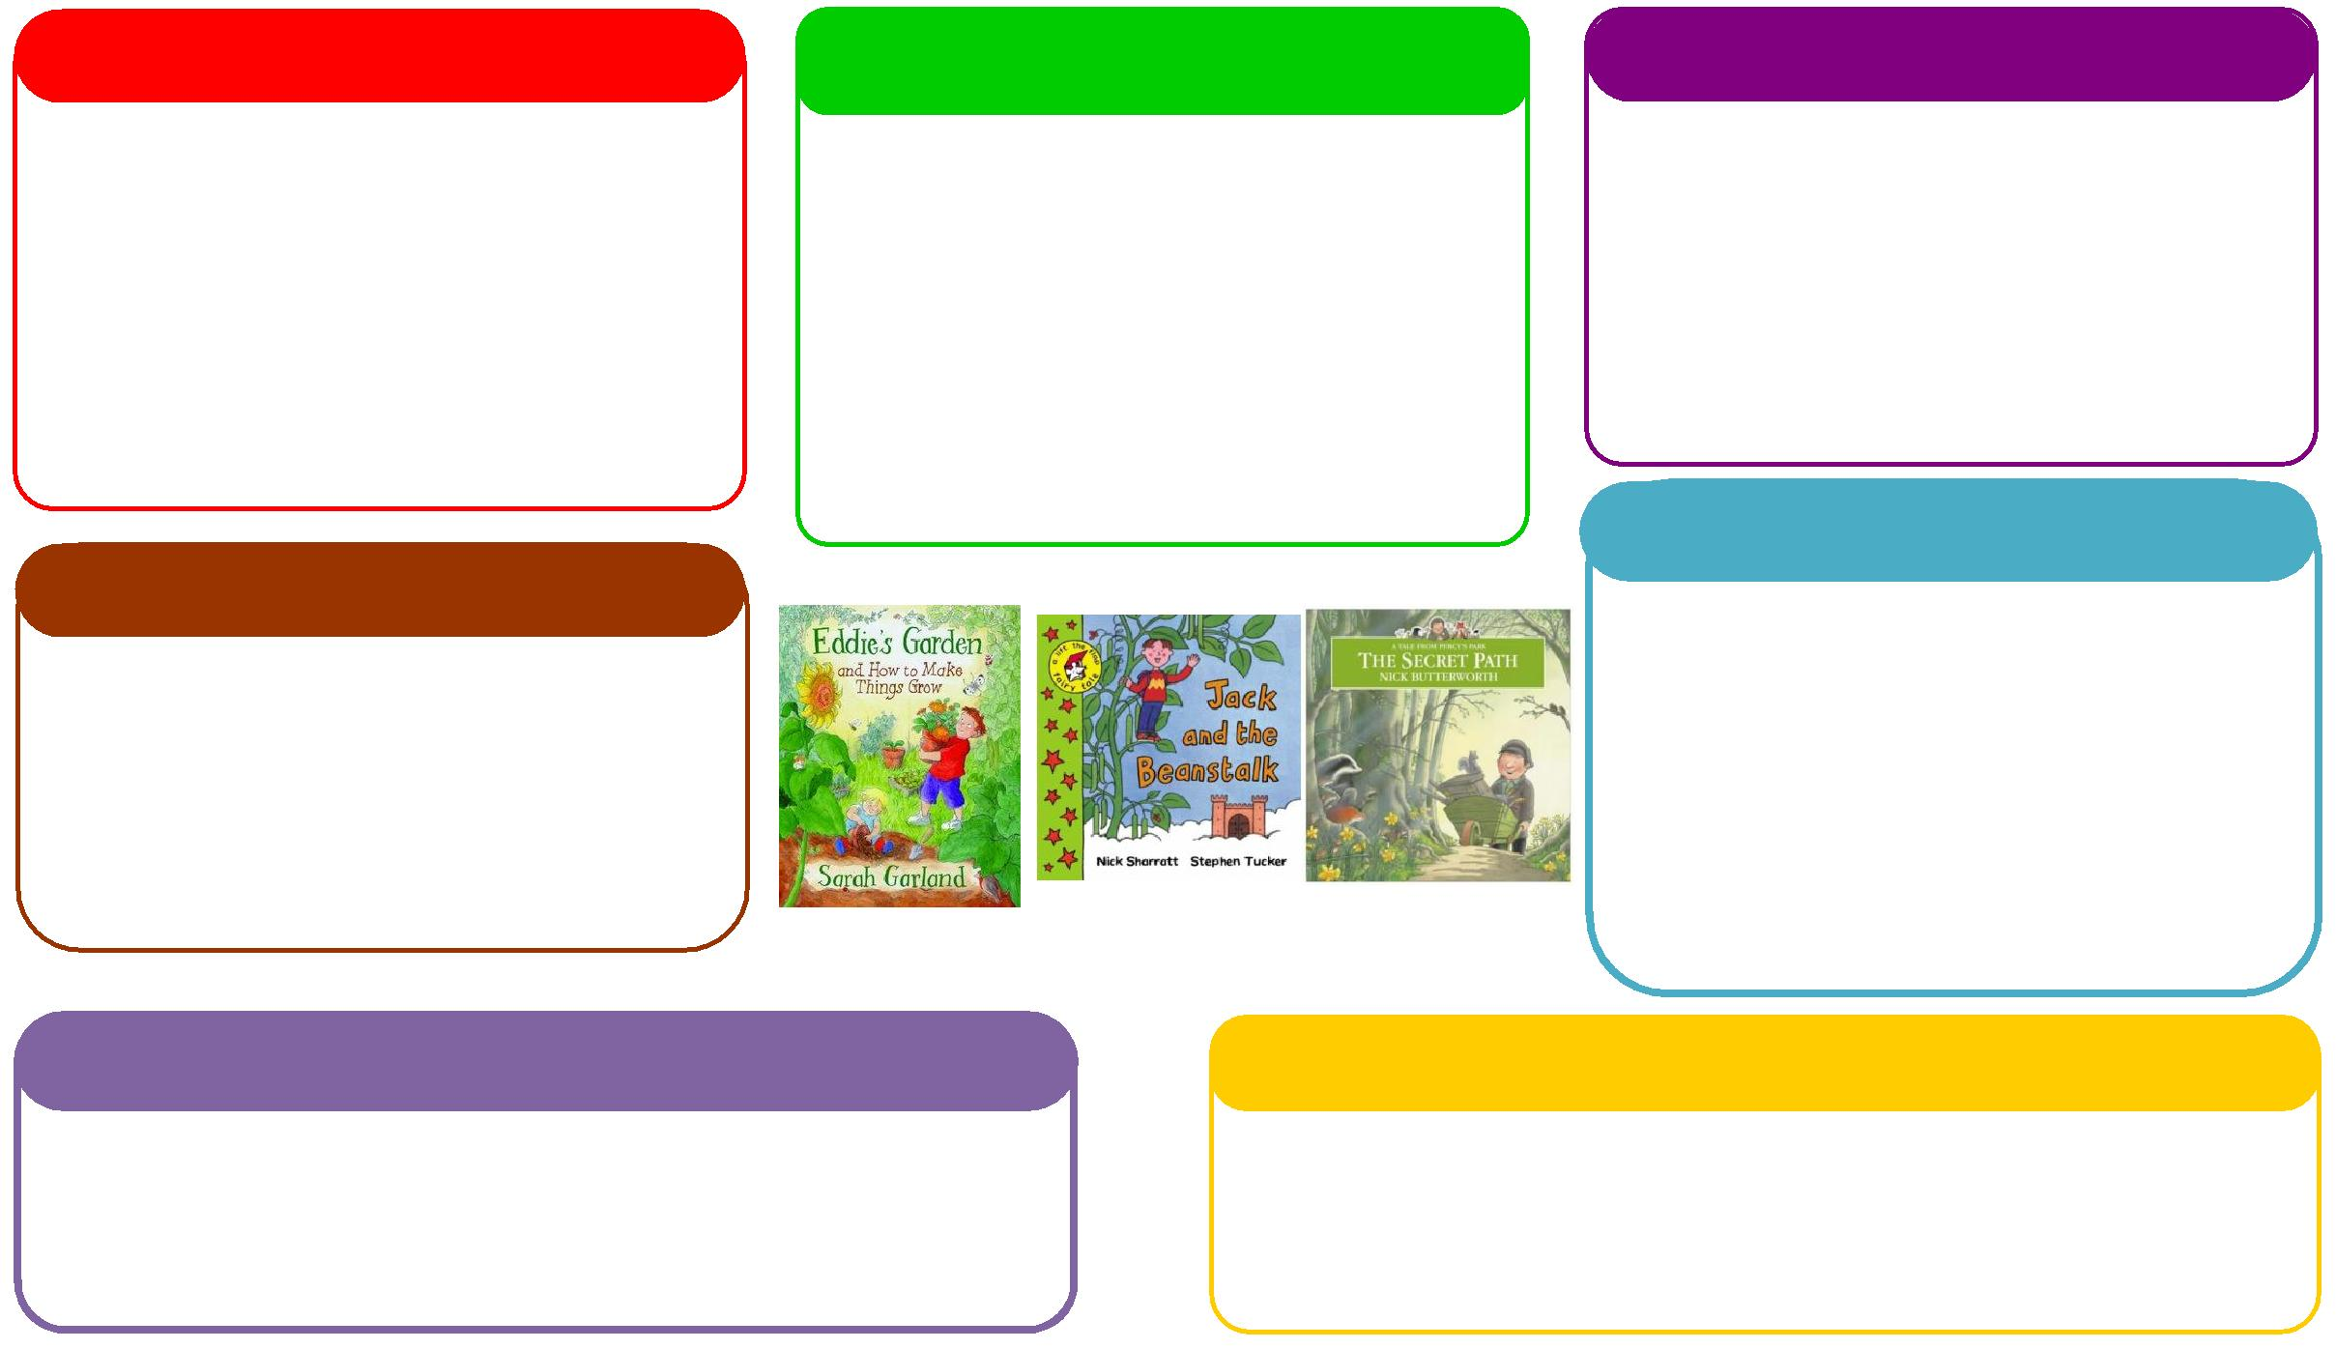

This half term we will be:

* Making porridge linked to our text choice
* Discussing and learning all about similarities and differences through festivals and celebrations,
* Investigating forces connected with the wind..

**Expressive Arts and Design**

**Personal, Social and Emotional Development**

**Understanding the World**

**Physical**

**Mathematics**

**Communication and Language**

**English**

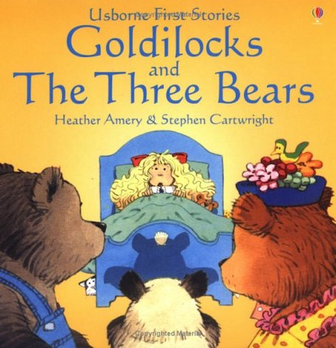 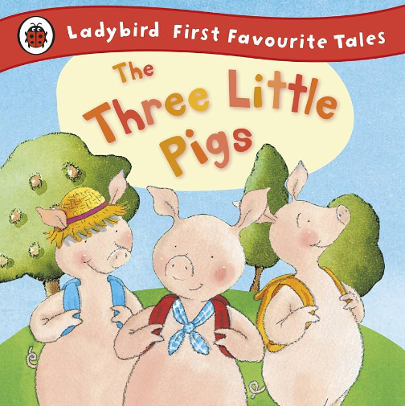

This half term we will be:

* Counting out objects from a larger set
* Ordering and writing numbers,
* Learning about size and shape,
* Using the maths area to practise our counting skills.

This half term we will be:

* Acting out different stories together,
* Using the story language in traditional tales,
* Talking about seasonal changes
* Learning to use words to communicate with each other

**Learning Letter Spring 1 EYFS**

Traditional Tales

This half term we will be:

* Crafts connected to our story books,
* Having gym lessons in the hall,
* Learning how to use different materials to create pictures,
* Learning new songs and rhymes,

This half term we will be:

* Discussing our classroom rules and why we have them,
* Looking at the different characters in the story and how they are feeling,
* Thinking about how to live a healthy lifestyle.

This half term we will be:

* Using our phonics knowledge to discriminate sounds and identify rhymes.
* Retelling stories,
* Talking about how we made porridge and what it tastes like,
* Mark making with writing equipment and recognising/writing our names.

This half term we will be:

* Manipulating playdough to represent things,
* Starting gym sessions in the hall.
* Learn how to control our bodies and use them in different ways in our outside area.

**EYFS Half Term Learning Project**

**How many Traditional Tales can you read at home? Which is your favourite Traditional Tale? Why is this your favourite? Can you create some art work in response to this story?**