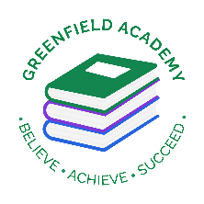**Greenfield Primary Academy**

**Year 4**

**Spring Term 2 Learning Letter 2024**

**In Maths we are learning to …**

**Place Value-** Recognise the place value of each digit in a 4d number

**Multiplication and Division** -  Use place value, known and derived facts to multiply and divide mentally.

**Decimals –** Round decimals to the nearest whole umber and compare decimals up to 2 decimal places

**Money -** Estimate, compare and calculate different measures, including money in pounds and pence.

**Memorise times tables. The children will be having a formal assessment of their times tables and will need to know both the multiplication and division facts for all tables up to 12. . Children need to use TTRockstars daily at home, and we will have an assessment in school each week.**

**In English we are learning to …**

**Write in different ways:** We will be looking at adventure stories with a theme, and writing our own, we will be writing an autobiographical account and a story poem.

**Read more fluently:** We will continue with our comprehension lessons three days a week, building on the skills we have been learning. We will continue to read in class with your child and they will also use MyOn – our online reading program.

**Understand Grammar:** We will continue to gather new vocabulary Use place value, known and derived facts to multiply and divide mentally. and will be using nouns, verbs, adjectives and prepositions. We will be using conjunctions for time and cause (for example *when*, *before*, *after*, *while*, *so*, *because) We will be using commas for fronted adverbials, prefixes, im, il, in, ir and writing sentences with more than one clause.*

**In RE we are learning…**

**Why is Jesus inspiring to some people?**

We will be learning to make connections between some of Jesus’ teachings and the way Christians live today To describe how Christians celebrate Christmas, Holy Week and Easter Sunday.

We will suggest some ideas about good ways to treat others, arising from their learning

**In Design Technology we are learning to …**

* Design a project that is strong and aesthetically pleasing
* Make a product using suitable materials that meets the design brief
* Look at our work and improve on our designs as we make it.
* Evaluate whether our work has met the design brief and talk about how we can improve next time.

**Our Learning Theme is …**

**Rainforests**

**In Science we are learning that …**

* Electricity is the presence and flow of [electric charge](https://kids.kiddle.co/Electric_charge).
* [electrons](https://kids.kiddle.co/Electrons)  travel through conductors such as [copper](https://kids.kiddle.co/Copper) wires.
* Electricity is a form of energy that comes in positive and negative forms
* electricity can occur naturally (lightning), or is produced.
* it is a form of [energy](https://kids.kiddle.co/Energy) which we use to power machines and electrical devices.
* Electricity can be dangerous, especially around water.
* Electricity comes from power stations, the wind, the sun and water.

**In Geography we are learning to …**

* describe and understand key aspects of:
  + **physical geography**, including: climate zones, biomes and vegetation belts, rivers, mountains, volcanoes and earthquakes
  + **human geography**, including: types of settlement and land use, economic activity including trade links, and the distribution of natural resources including energy, food, minerals and water

This will all be taught by studying the rainforest, and its importance for the health of the planet.

**In RHE/ PSHE we are learning about …**

* that healthy friendships make people feel included; recognise when others may feel lonely or excluded; strategies for how to include them
* how friendships can change over time, about making new friends and the benefits of having different types of friends
* that friendships have ups and downs; strategies to resolve disputes and reconcile differences positively and safely
* strategies to respond to hurtful behaviour experienced or witnessed, offline and online (including teasing, name-calling, bullying, trolling, harassment or the deliberate excluding of others); how to report concerns and get support
* about respecting the differences and similarities between people and recognising what they have in common with others e.gphysically, in personality or background
* (R33) to listen and respond respectfully to a wide range of people, including those whose traditions, beliefs and lifestyle are different to their own

Any questions? Please ask us at the door when you collect your child.

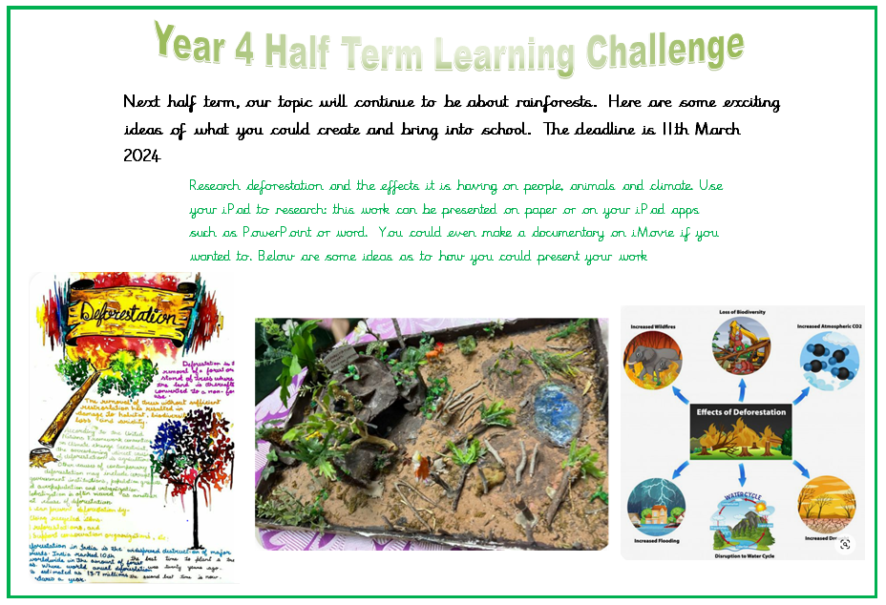

**Rainforests**

Research deforestation and the effects it is having on people, animals and climate. Use your iPad to research: this work can be presented on paper or on your iPad apps such as PowerPoint or word. You could even make a documentary on iMovie if you wanted to.

**Year 4 Half Term Learning Project**

**Year 4 Weekly Home Learning Tasks**

**READING**

Please share your child’s reading book with them, as **10-15 minutes** of reading **every day** at home can make a lot of difference to your child's reading ability.

Your child MUST bring their book bag into school **every day** so an adult can read with them on their reading day, and any extra days if there is an opportunity.

Each child will have a reading book, and an extra book from the class library.

Every child will have an online MyOn account where they can read books and answer questions. This is in addition to their daily reading book task.

**MATHS**

Every child has a TTRockstars and Numbots account. They can use these to practise their number bonds and times tables facts online. 10 minutes **every day** will mean they will be ready for their times tables test in June, and will make them much quicker at working things out in class.

**PURPLE MASH**

Each week the children will be set several tasks on Purple Mash. They log on to their account and complete their tasks. When they log on, there is a bell at the top of the screen. When they click on this, it will show them all the tasks they need to complete for that week.

Tasks are allocated on a Friday and have to be completed by the following Tuesday. There is usually a grammar, writing, spelling, maths and either a science or geography task.