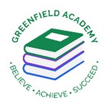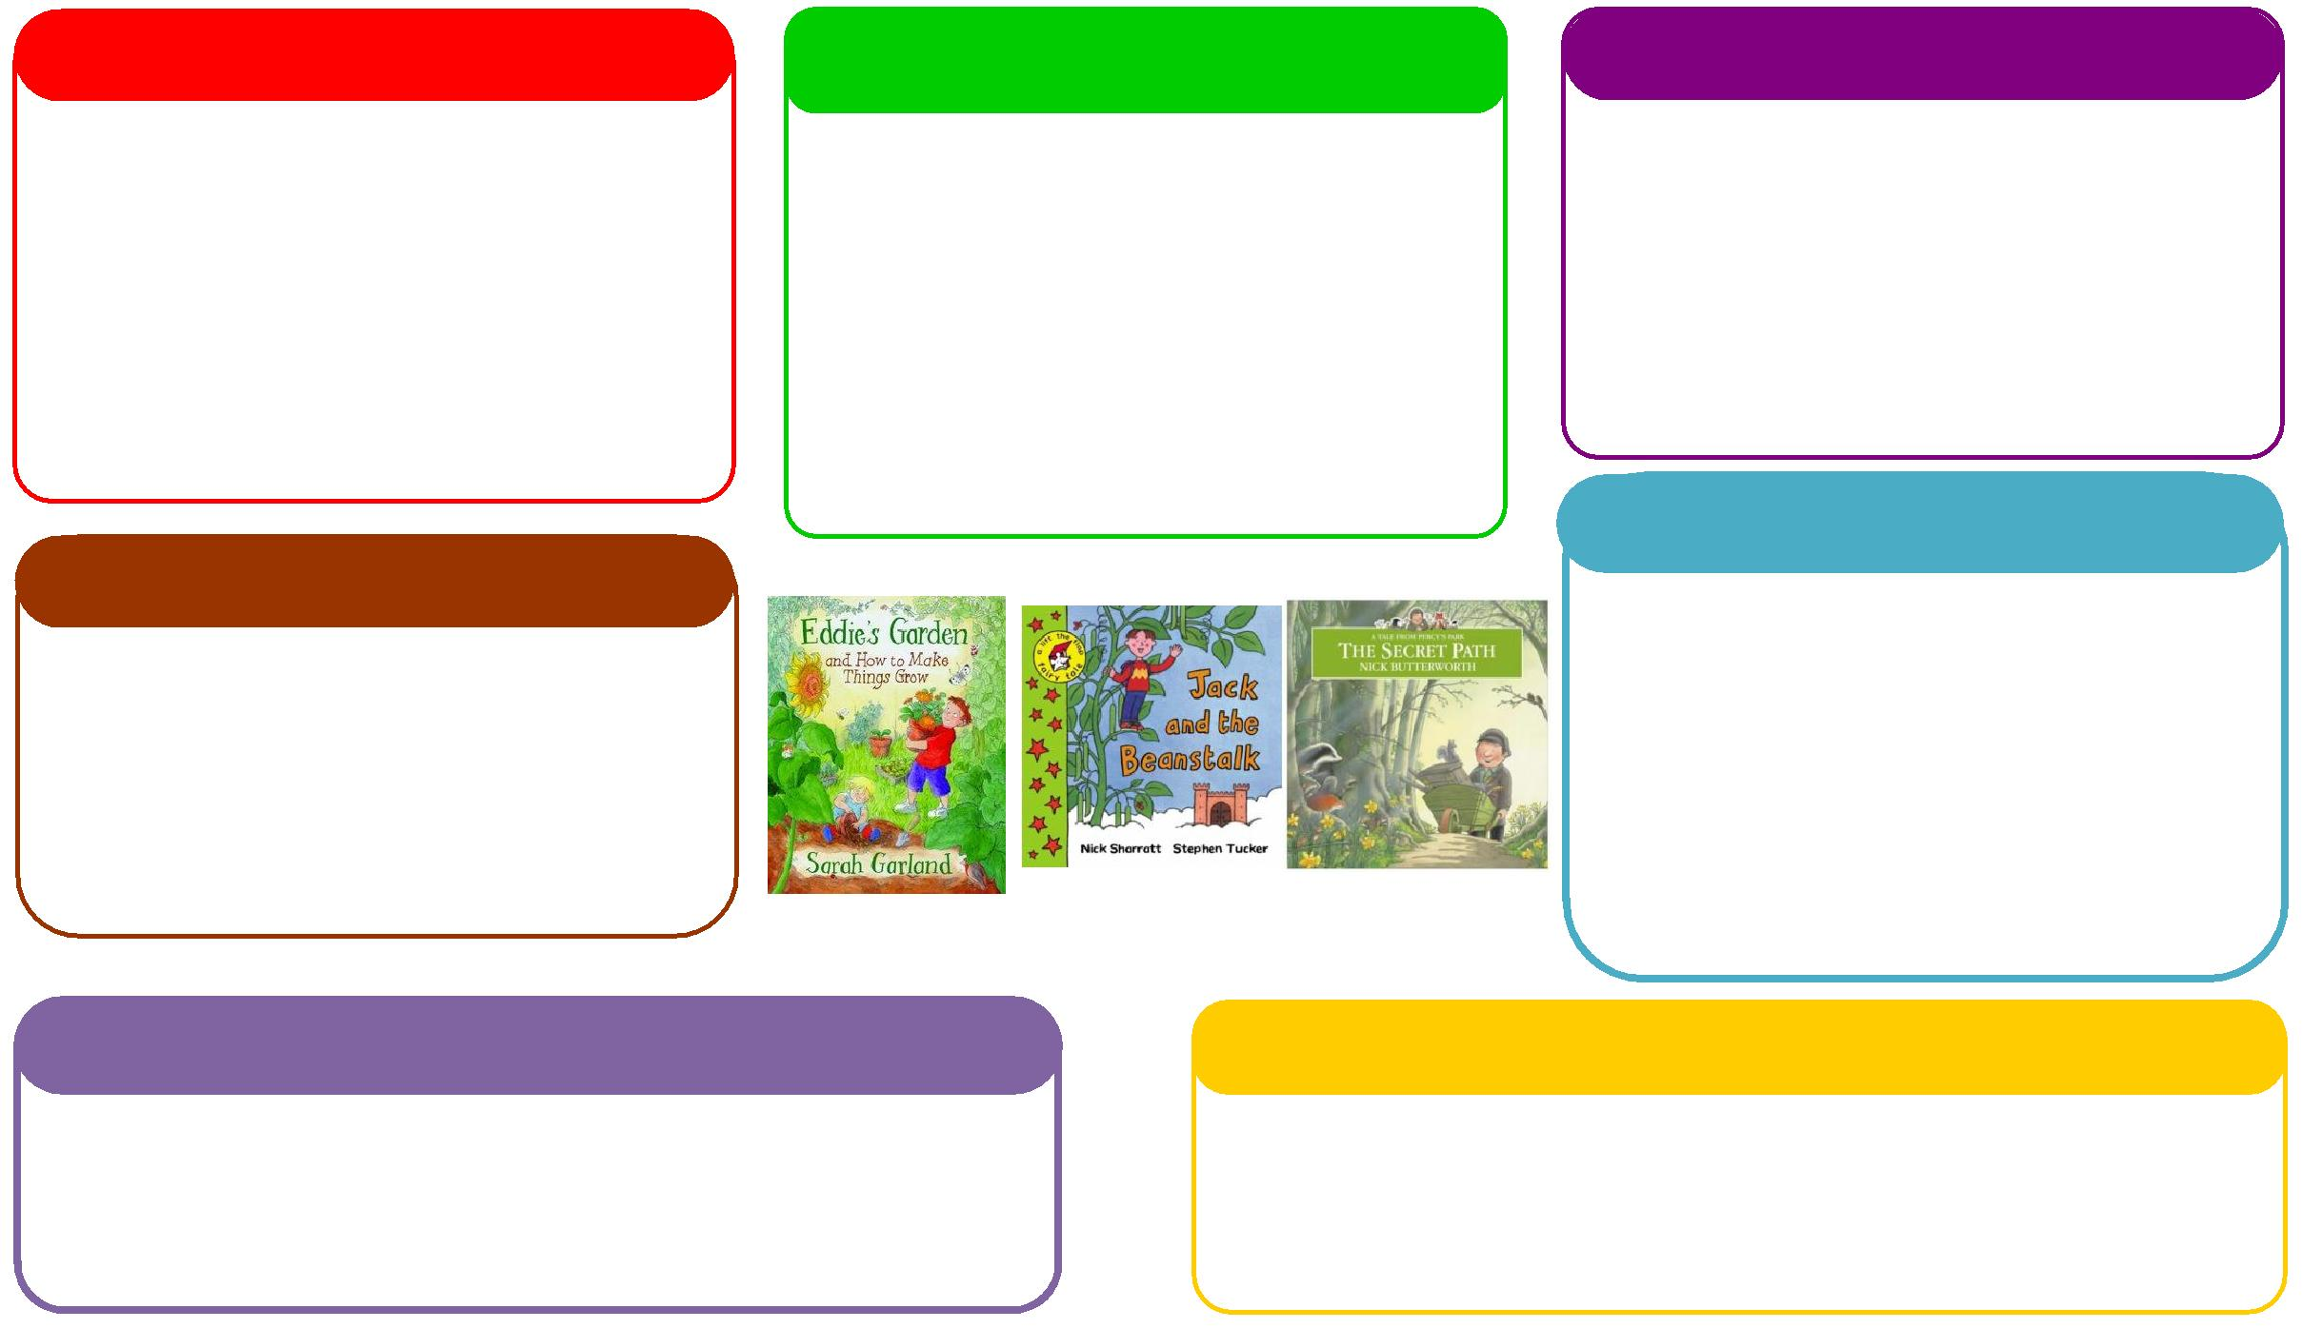

This half term we will be:

* Researching dinosaurs and writing facts about them,
* Going on a spring walk to look at seasonal changes,
* Programming Bee Bots,
* Learning about Easter and why it is special.

**Expressive Arts and Design**

**Personal, Social and Emotional Development**

**Understanding the World**

**Physical**

**Mathematics**

**Communication and Language**

**English**

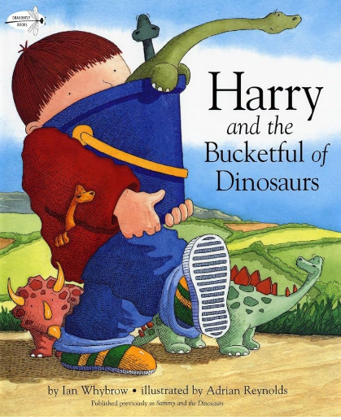 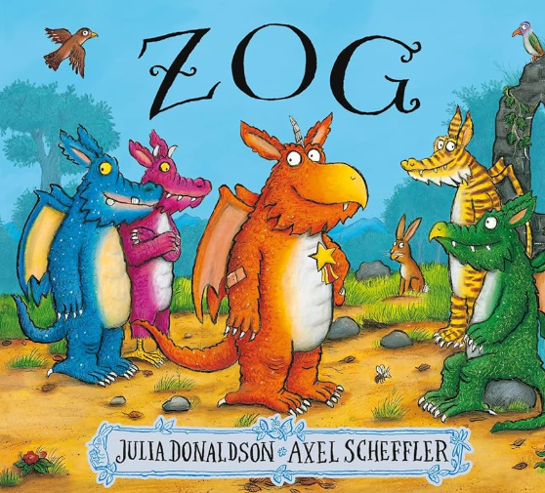

This half term we will be:

* Practical subtraction
* Missing number calculations within 5,
* Missing number calculations within 10,
* Spatial reasoning,
* Starting to chant in tens and twos.

This half term we will be:

* Discussing with our friends what we got up to in the holidays,
* Acting out different stories together,
* Using Modern tales to inspire our own helicopter stories,
* Talking about seasonal changes

**Learning Letter Spring 2 EYFS**

Modern Tales

This half term we will be:

* Creating dinosaur crafts,
* Having dance lessons in the hall,
* Making Easter crafts,
* Learning new songs and rhymes,

This half term we will be:

* Discussing our half term holidays and what we got up to,
* Looking at the different characters in the story and how they are feeling,
* Thinking about how to live a healthy lifestyle.

This half term we will be:

* Using our phonics knowledge to write words and simple sentences,
* Retelling stories,
* Researching dinosaurs and writing facts on them,
* Creating ZOG books.

This half term we will be:

* Making magic wands with sticks outside for large arm moment,
* Exploring the new digging area outside,
* Exploring the new weaving area outside,
* Going on a local walk to explore seasonal changes,

**EYFS Half Term Learning Project**

**How many Traditional Tales can you read at home? Which is your favourite Traditional Tale? Why is this your favourite? Can you create some art work in response to this story?**