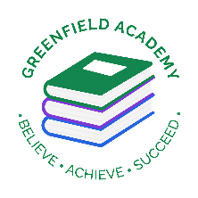**Greenfield Primary Academy**

**Year 5**

**Summer 2 Term Learning Letter 2024**

**In English Our focus will be:**

* **Playscripts based on our King Lear play**
* **Two weeks of Oliver Twist which links to our Victorian topic – we will write a newspaper report and a diary entry**
* **Grimms Fairy Tale based on Red Riding Hood, where we will write a persuasive letter and our own traditional tale**

**In Math we are studying:**

* **Angles – acute, obtuse, reflex,**
* **Right angles, angles in a straight line**
* **Triangles**
* **Quadrilateral**
* **Statistics**
* **Fraction, Decimal and Percentages**

**In RE we are studying: Green religion? How and why should religious communities do more to care for the Earth?**

* **Does Earth belong to God?**
* **Muslims and environment.**
* **Christians and environment**
* **Hindus and environment**
* **Jewish and environment**

**In D.T we will learn how to make moving toys.**

* **Toys with cam mechanisms**
* **Different types of cams**
* **Design a toy with cam mechanism**
* **Make cam mechanism toys.**

**Our Learning Theme is**

**The Victorians**

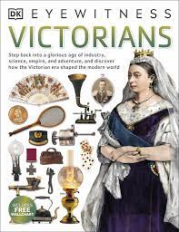

**In Science we are studying Living things.**

* **Differences in life cycles**
* **Explore Jane Goodall and her work with Chimpanzees**
* **Create own animal and write a non-chronological report including life cycle.**

**In History we are studying The Victorians.**

* **Industrial Revolution**
* **How attitudes to children changed over time.**
* **Victorian time inventions**
* **Greatest impact from Victorian time.**
* **Impact of Victorian period on present day.**

**In RHE/ PSHE out theme is Health and Well-being. We will be studying how we change and grow.**

* **What makes up health. . Know where to seek help for health**
* **Physical illness . Recognise change in bodies**
* **Effects of lack of sleep . Understand emotional changes**

 In Year 5 there is a certain expectation when it comes to Home Learning. Please see this outlined below:

**Individual Reading Books**

All children must read a few pages each night at home and write a comment in their reading diary.

**MyOn**

Children are expected to complete MyOn reading everyday with books of their choice online.

**TT Rockstars**

Children will be set 25mins (5 mins daily) of TTRockstars to practise their times tables.

**SumDog**

Children will be set a task on SumDog where they have 50 questions to answer based on their learning in class that week.

**Spellings**

Children will have spelling practise to complete based on those words they found tricky in the lesson that week and a spelling quiz on Purple Mash.

**Home Learning is set on a Friday and is expected to be completed by Tuesday morning.**

We would like children to spend time practicing their lines for the performance of Shakespeare’s Twelfth Night which will take place at the Middleton Arena on the 19th July at 6pm.

Ticket information will be coming soon.

Our other Part of the Half term project is for children to Research a Victorian invention.

**Year 5 Half Term Learning Project**

**Year 5 Weekly Home Learning Tasks**