**Summer 1 Half Term Project**

**The Victorians**

Over this half term, our history learning will be focused upon the Victorians. The Victorian era is the time when Queen Victoria was on the throne of the UK. She came to the throne in 1837 and died in 1901.

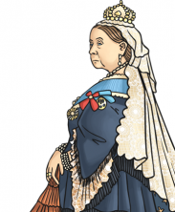

The Victorian Era was a very productive time for new inventions. Many household devices that we take for granted today were invented during this period. Here are some of the inventions. How many do we use everyday?

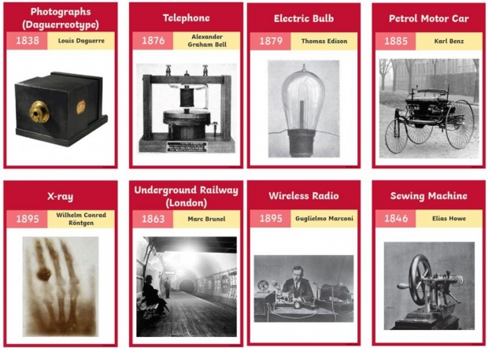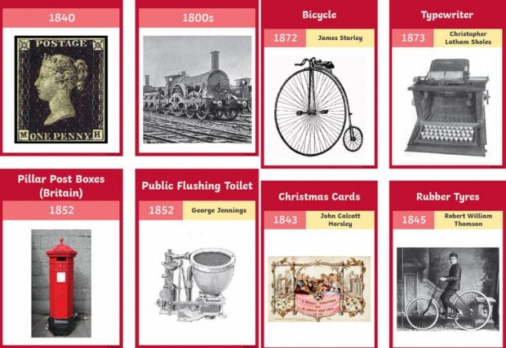

Your task is to research one of these inventions and the person who invented it. Then create a fact file about it and its inventor. You can present the information in this fact file however you wish. Be as creative as possible!

You could include information such as:

* Who was it that invented the invention?
* What was their occupation, what was their family life like? What was their childhood like?
* What’s does the invention do? What does it look like?
* How did the inventor come up with their idea?
* What makes their invention so special?
* How does their invention effect modern life?

***Extra challenge***

Can you create a detailed pencil sketch of your invention? Look closely at pictures and recreate this.

Remember to think about tone and shading of your invention. Does it have any marks on it, any patterns? Think about where the light is coming from. Are there any shadows?

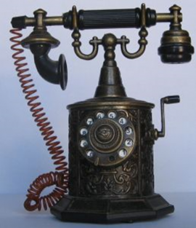

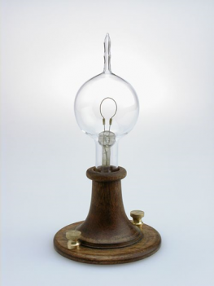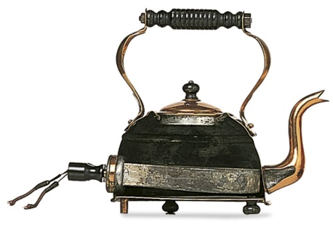

We cannot wait to see your learning and sketches. Please bring them in on Friday July 5th 2024