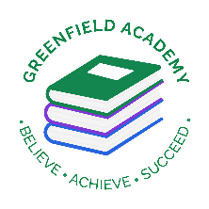**Greenfield Primary Academy**

**Year 5**

**Autumn Term Learning Letter 2024**

**In English we are studying Shakespeare where we will:**

* **Retell the picture book of The Boy, The Bear, The Baron, The Bard**
* **Study one of Shakespeare’s play and write our own playscript**
* **Write diaries and biographies as well as character profiles.**

**We will also focus on grammar skills: conjunctions, use of inverted commas for speech, brackets and commas.**

**In Maths we are learning:**

* **Place Value to 10 million including comparing and ordering numbers.**
* **How to round numbers and use negative numbers.**
* **How to use formal written methods to calculate the four operations - + x and ÷**

**Our Learning Theme is …**

**TUDORS**

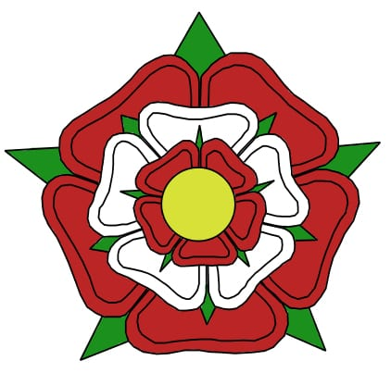

**In RE we are studying:**

**We will be looking at Why do some people believe God exists?**

**We will look at religious and non-religious groups about the nature of belief in God. This will include Christians and Humanist views of God and what impact this has on their daily lives.**

**In Art we are learning to:**

* **Make mini portraits based on Tudor people.**
* **Learn how to draw portraits**
* **Creating a miniature family tree of the Tudors.**

**In Science we are learning about Forces. This will include:**

* **Explain that unsupported objects fall towards the Earth because of the force of gravity acting between the Earth and the falling object**
* **Identify the effects of air resistance, water resistance and friction, that act between moving surfaces**
* **Recognise that some mechanisms including levers, pulleys and gears allow a smaller force to have a greater effect**

**In History we are learning about:**

* **The Tudors**
* **The Battle of Bosworth**
* **Tudor Monarch**
* **Henry VIII and his six wives**
* **Reformation**
* **Spanish Armada**

**In PSHE we are learning about:**

* **Rights and responsibilities, why manners, courtesy and respect are important.**
* **Democracy and voting as well as leaning that self-respect is important to our own happiness.**
* **How to respect others and treat them how we expect to be treated**

This half term we are learning about The Tudors.

Whilst we are focusing on the monarchy and changes during class time, we would like you to create a project on Tudor life.

You may choose to focus on housing, food or crime and punishment.

You could produce a model, fact book, research project or an amazing piece of artwork. We are looking forward to seeing how creative you can be.

Please ensure these are handed in to your class teacher by the **18th October**, ready for viewing in the final week. We are extremely excited to see what you can create and find out.

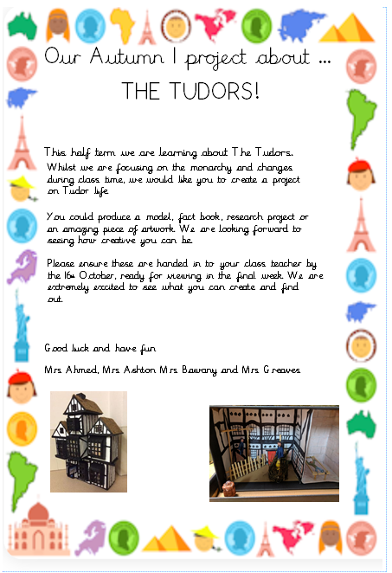

**Year 5 Half Term Learning Project**

**READING**

Please share your child’s reading book with them, as **10-15 minutes** of reading **2x** at home can make a lot of difference to your child's reading ability.

Your child MUST bring their book bag into school **every day** so an adult can read with them on their reading day, and any extra days if there is an opportunity.

They must also log in to MYON and read book and answer the questions 2x week.

**MATHS**

Children must continue to log in and use TTRockstars to practice their times tables and Sumdog to help support their maths learning 2x a week

**Year 5 Weekly Home Learning Tasks**