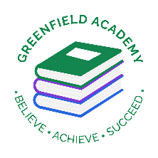**Greenfield Primary Academy**

**Year 4**

**Autumn Term 2 Learning Letter 2024**

**In Maths we are learning to …**

* Count in multiples of 6,7,9, **25 and 1000**
* Find 1000 more/less than a given number
* Use place value, know and derived facts to multiply and divide mentally, including: multiplying by 0 & 1;
* Recall multiplication and division fact for multiplication tables up to 12 x 12
* Use place value, know and derived facts to multiply and divide mentally, including: multiplying by 0 & 1; multiplying together 3 numbers,
* Count up and down in hundredths;
* Compare numbers with the same number of decimal places up to 2decimal places.
* Estimate, compare and calculate different measures,

**In English we are learning to …**

**Write in different ways:** we will be looking at the features of myths and legends, report writing, recounts and adverts, and using figurative and expressive language through poetry. We will be writing our own character descriptions, recounts, reports and poems.

**Read more fluently:** this term we will continue with whole class comprehension lessons in the same way as Year 3. Your child will have a reading book and will also have access to MyOn – our online reading program.

**Understand Grammar:** we will learn about: Nouns, verbs, adjectives, prepositions, apostrophes (possession), inverted commas, fronted adverbials, commas with fronted adverbials and to

express time, place and cause

**Our Learning Theme is …**

**The Greeks**

**Sound**

**In RE we are learning …**

How do people from religious and non-religious communities celebrate festivals?

Describe how the way some people celebrate festivals might show something about their beliefs

Identify some differences in the way festivals (e.g. Christmas) are celebrated within and between different religious and non-religious world views

**In Art we are learning to …**

* to sketch a design based on examples from Ancient Greece
* plan, design, create and finish a clay pot
* evaluate their own and other’s work to identify how to improve it

**In Science we are learning that …**

Identify how sounds are made, associating some of them with something vibrating.

Recognise that vibrations from sounds travel through a medium to the ear.

Find patterns between the volume of a sound and the strength of the vibrations that produced it.

Find patterns between the pitch of a sound and the features of the object that produced it.

Recognise that sounds get fainter as the distance from the sound source increases.

**In History we are learning to …**

* Place some historical periods in a chronological framework.
* Use historic terms related to the period of study.
* Use sources of information in ways that go beyond simple observations to answer questions about the past.
* Use a variety of sources to find out about aspects of life in the past.
* Communicate learning in an organised and structured way, using appropriate terminology.
* Describe a study of Ancient Greek life and achievements and their influence on the western world

**In RHE/ PSHE we are learning to …**

* In Year 4, children look into further detail about what physical and mental health is. They will become more self-aware and gain a deeper understanding of emotions and learn how to set goals to cope with these.

**Ancient Greeks**

For your half term project we would like you to do some research on Ancient Greece. You can present your work in a PowerPoint presentation, a video diary or a double page spread with pictures. You could even make a Greek artefact or model to be displayed in the classroom.

Be creative and we will look forward to seeing your projects, which are due back in school on **Friday 29th November**.

Deadline for this project is November 29th. The Home Learning Challenge poster will be displayed at the class parent notice board window.

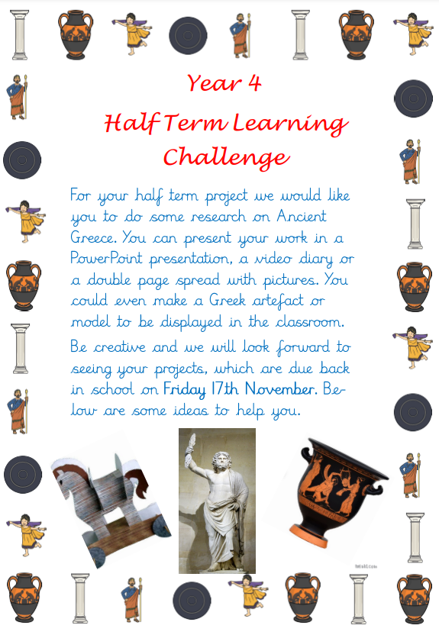

**Year 4 Half Term Learning Project**

**Year 4 Weekly Home Learning Tasks**

**READING**

Please share your child’s reading book with them, as **10-15 minutes** of reading **every day** at home can make a lot of difference to your child's reading ability.

Your child MUST bring their book bag into school **every day** so an adult can read with them on their reading day, and any extra days if there is an opportunity.

Each child will have a reading book, and an extra book from the class library.

Every child will have an online MyOn account where they can read books and answer questions. This is in addition to their daily reading book task.

**MATHS**

Every child has a TTRockstars, they can use these to practise their times tables facts online as it is important times tables are learnt for this year. 10 minutes **every day** will mean that they are ready for their times tables test in Summer, and will make them much quicker at working things out in class.