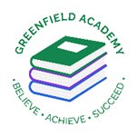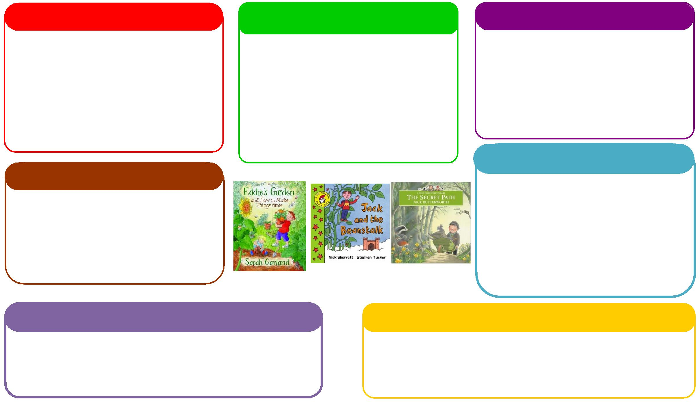

This half term we will be:

* Learning about different occupations.
* Discussing and learning all about similarities and differences through festivals and celebrations,
* To use all their senses in hands-on exploration.

**Expressive Arts and Design**

**Personal, Social and Emotional Development**

**Understanding the World**

**Physical**

**Mathematics**

**Communication and Language**

**English**

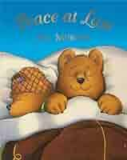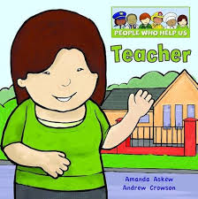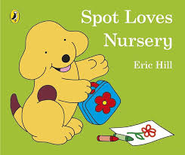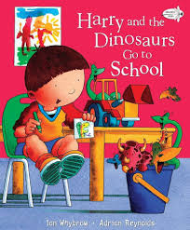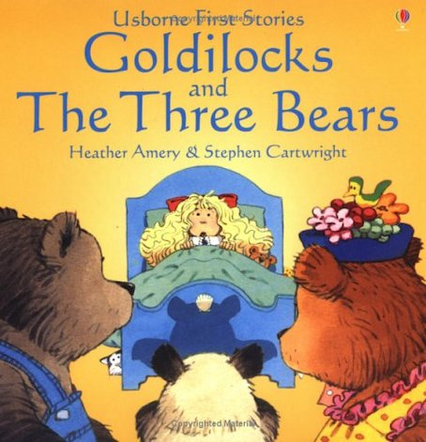 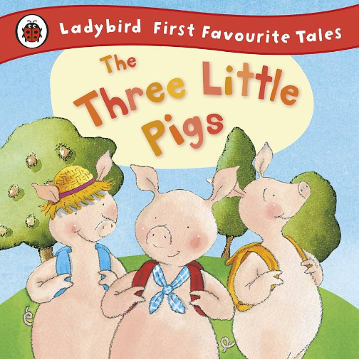

This half term we will be:

* Chanting numbers and counting 5 objects
* Ordering and writing numbers,
* Learning about weight, shape and patterns,
* Using the maths area to practise our counting skills.

This half term we will be:

* Acting out different stories together,
* Learning the words of the classroom
* Talking about seasonal changes
* Learning to use words to communicate with each other

**Learning Letter Autumn 2 EYFS**

People Who Help Us

This half term we will be:

* Crafts connected to our story books,
* Learning how to use different materials to create pictures,
* Learning new songs and rhymes,

This half term we will be:

* Discussing our feelings during the day.
* Looking at the different ways we can stay safe.
* Thinking about how to live a healthy lifestyle.

This half term we will be:

* Using our phonics knowledge to discriminate sounds and identify rhymes.
* Retelling stories,
* Talking about who helps us and what do they do?
* Mark making with writing equipment and recognising/writing our names.

This half term we will be:

* Manipulating playdough to represent things,
* Starting dance sessions in the hall.
* Learn how to control our bodies and use them in different ways.

**EYFS Half Term Learning Project**

Who helps you at home? Bring a photo in of them and tell us all about what they do!