**Year 6 Half Term Project Spring 1**

Next half term we will be studying Evolution, Inheritance and Adaptation in Science.

For your project we would like you to ***Design your own species.*** You can choose where they live from the habitats below and then think about what adaptations they need in order to survive there. For example, polar bears have large paws with retractable claws to help them dig into snow in their icy habitats.

The habitats are:

* Polar
* Desert
* Rocky shore
* High altitude
* Rainforest
* Deep sea

Think about what the habitat’s climate is like (we can give you information to help with this), then think about the animals you know you would find there and what features they have to help them survive.

You can either create a 3D model of your species or a drawing. You must have information about the species you have created, for example, its name and features to help it survive. See the example below.

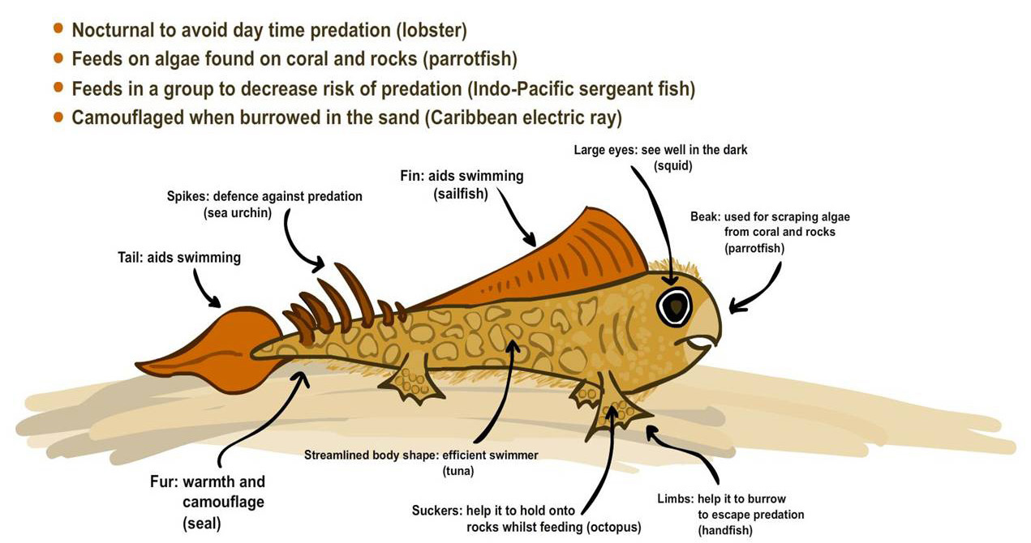

The project is due in **Monday 3rd February**

Have fun being creative!

Miss Begum