**Greenfield Primary Academy**

**Year 1**

**Spring Term 1 Learning Letter 2025**

**In English this half term we will read and explore stories on our capital city of London. In our first story ‘The Queen’s Hat’ we will learn to describe ‘The Queen’ using our best adjectives and our learning from Jubilee Week. We will read and re-write the story of ‘The Queen’s Handbag’ and then compare it to the story of ‘The Queen’s Hat’ in a book comparison. Finally, we will write a description of Paddington Bear and write a recipe and party invitation to a tea with him.**

**In Maths we will continue to learn how to add and subtract numbers up to 20 and use our number bonds to 20 to help us to solve maths problems**

**We will continue our work on one more and one less up to 20 and order numbers within 20. We will also learn how to count in 2’s and 5’s.**

**We will also learn how to measure capacity and also learn positional and directional language.**

**In Art we are learning to create a collage. We will study the work of a famous painter called Monet who painted landmarks of London. We will study the techniques of collage and think about the materials we can use to create different effects. We will then use our skills to create a collage of a London Landmark**.

**Our Learning Theme is …**

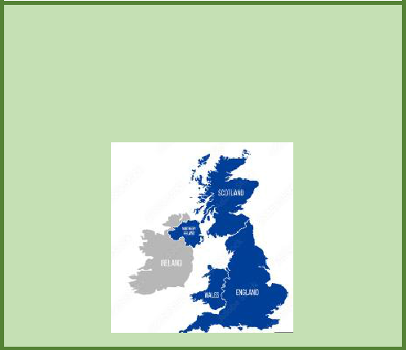

**‘Great Britain ’**

**In RE we are learning all about the Muslim faith. We will recognise and describe objects that are precious to Muslims and understand why the stories in the Quran are important to Muslims. We will learn all about what happens at mosque and share our own experiences**.

**In Geography we will study the location of the UK on a world map and then learn the four countries and capital cities of the UK. We will learn the names of the surrounding seas and think about the seas we need to cross to get to other places. We will sort physical and human features of Wales, Scotland and England and write about what we have learnt in an information poster.**

**In Science we are learning about animals and their different characteristics. We will look at the similarities between mammals, fish, amphibians, birds and reptiles. We will also talk about the animals we know and if they are wild animals or if they are pets.**

**In RHE/ PSHE we will be learning about Keeping safe. We will learn about a range of different safety measures we can take to keep safe including medicine safety, sun safety, road safety, e-safety and personal and emotional safety. We will also learn that having enough rest can make us feel better and improve our emotional safety.**

**Year 1 Weekly Home Learning Tasks**

**READING**

Please share your child’s reading book with them, as **10-15 minutes** of reading **every day** at home can make a lot of difference to your child's reading ability.

Your child MUST bring their book bag into school **every day** so an adult can read with them on their reading day, and any extra days if there is an opportunity.

Please complete your reading book and comprehension questions on Phonics Bug each week which can be found in your Phonics Bug library.

**MATHS**

Practise counting forwards and backwards to 20. Use a number line to recognise and develop your child’s number formation and recognition of numbers up to 20.

Remember to check your child’s pink book every Friday for their homework.

**Year 1 Half Term Learning Project**

