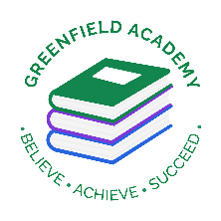**Greenfield Primary Academy**

**Year 3**

**Spring Term 1 Learning Letter 2024**

**In Maths we are learning to …**

In Maths, we will be exploring numbers up to 4 digits and addition and subtraction, and we will be:

- Compare and order numbers up to 1000. Solve number problems and practical problems involving these ideas. Recognise the place value of each digit in a three-digit number (hundreds, tens, ones)

- Add and subtract numbers mentally, including a three-digit number and 1s, 10s and 100s. Add and subtract numbers with up to 3 digits, using formal written methods of columnar addition and subtraction

- Add and subtract amounts of money to give change, using both £ and p in practical contexts

- Draw 2-D shapes and make 3-D shapes using modelling materials; recognise 3-D shapes in different orientations and describe them

- measure, compare, add and subtract: lengths (m/cm/mm); mass (kg/g); volume/capacity (l/ml)

**In English we are learning to …**

**Write in different ways:** Suspense stories, Imagination stories, Instructions and calligrams.

They will be studying the following book:

**Escape from Pompeii**

and the film **Lava**

**Read more fluently:** this term we will continue with whole class comprehension lessons. Your child will have a reading book and will also have access to MyOn – our online reading program.

**In Art we are learning…Collage and textiles** (Mixed materials) Volcanoes

-Show an awareness and name a range of different fabrics/ materials

 -Use a sketchbook to plan, collect and develop ideas ---Fabric)

Develop skills in cutting and joining

-Use collage as a means for collecting ideas

**Our Learning Theme is …**

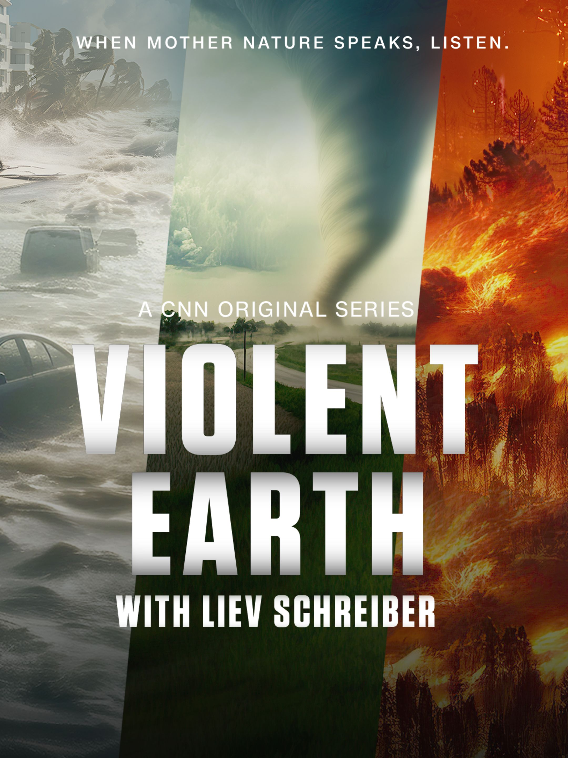

**In RE we will explore the questions …**

Why is the Bible important to Christians today?

- some Bible stories that inspire Christians.

- at least two ways Christians use the Bible in everyday life. ​

- some ways Christians say God is like, with examples from the Bible, using different forms of expression.

**In Geography we are learning to … Earthquakes and**

**Volcanoes**

**-** Name the features of a volcano ​

- Identify where volcanoes and earthquakes occur ​

- Explain why volcanoes and earthquakes occur​

​

**In Science we are learning… Rocks and Soils**

-compare and group together different kinds of rocks on the basis of their appearance and simple physical properties

- describe in simple terms how fossils are formed when things that have lived are trapped within rock

-recognise that soils are made from rocks and organic matter.

**In RHE/ PSHE we are learning to … Resilience / Keeping safe**

- I know that I can get help if I am being bullied

- I know that people can be bullied online, and this can affect my mental health *(Cyber bullying)*

- I know how to keep safe when using the tram, railway and roads

**Year 3 Half Term Learning Project**

**Year 3 Weekly Home Learning Tasks**

**READING**

Please share your child’s reading book with them, as **10-15 minutes** of reading **every day** at home can make a lot of difference to your child's reading ability.

Your child MUST bring their book bag into school **every day** so an adult can read with them on their reading day, and any extra days if there is an opportunity.

Each child will have a reading book, and an extra book from the class library.

**MATHS**

Each child has received a copy of multiplications to 12. Please use this to work with your child so they become more confident with their times table knowledge.

**PURPLE MASH**

Each week the children will be set several tasks on Purple Mash. They log on to their account and complete their tasks. When they log on, there is a bell at the top of the screen. When they click on this, it will show them all the tasks they need to complete for that week.

Tasks are allocated on a Friday and have to be completed by the following Tuesday. There is usually a grammar, writing, spelling, maths and a Topic task.

**Swimming**

The children will continue to go swimming weekly.

**P.E**

P.E kits are needed every Friday.

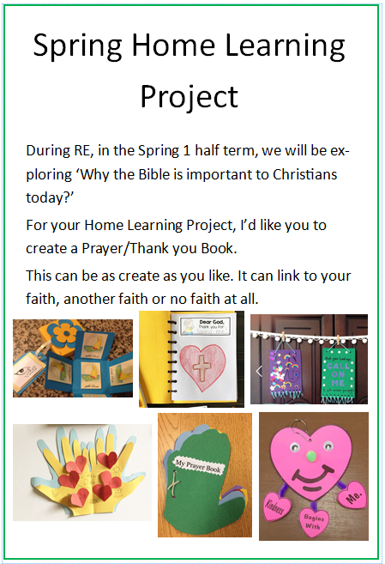Due back on Monday 27th January