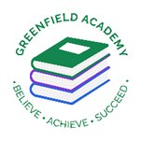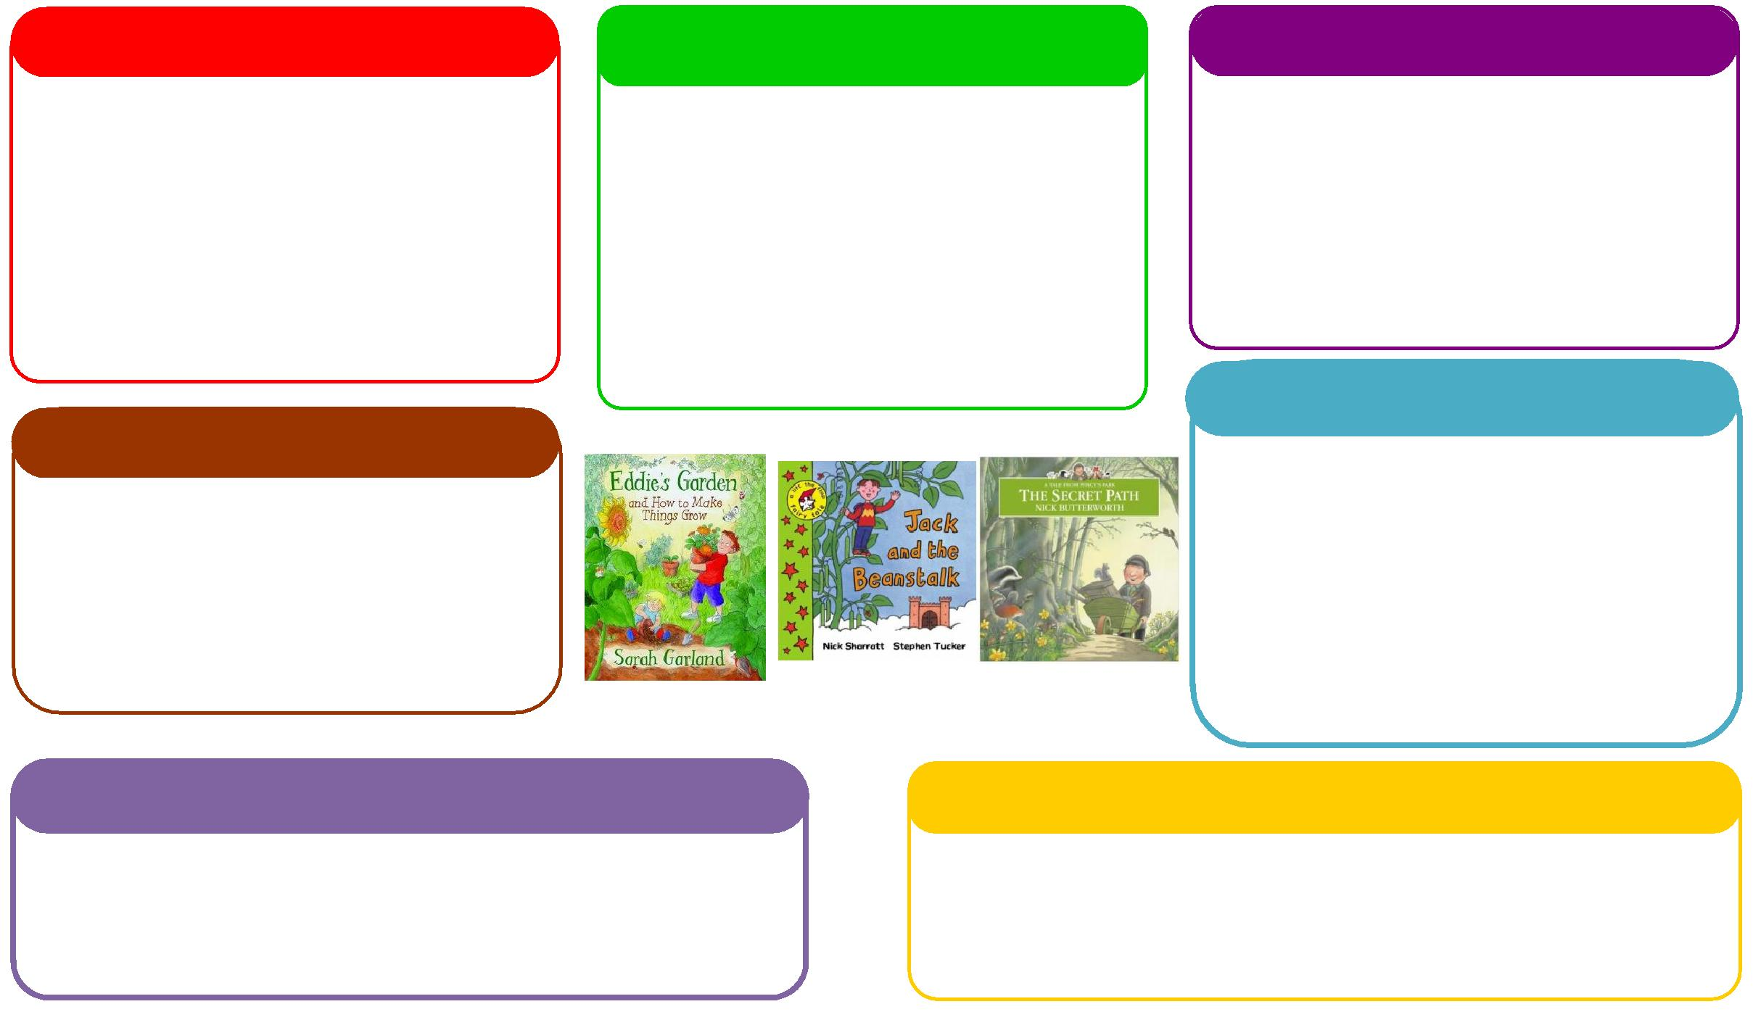

This half term we will be:

* Making porridge linked to our text choice
* Discussing and learning all about similarities and differences through festivals and celebrations,
* Investigating forces connected with the wind..

**Expressive Arts and Design**

**Personal, Social and Emotional Development**

**Understanding the World**

**Physical**

**Mathematics**

**Communication and Language**

**English**

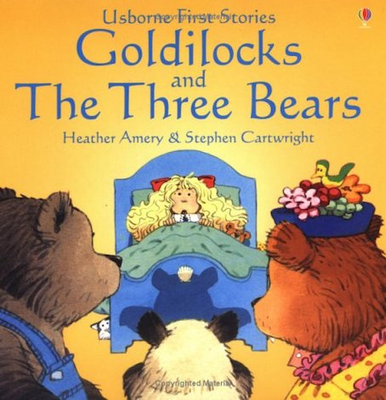 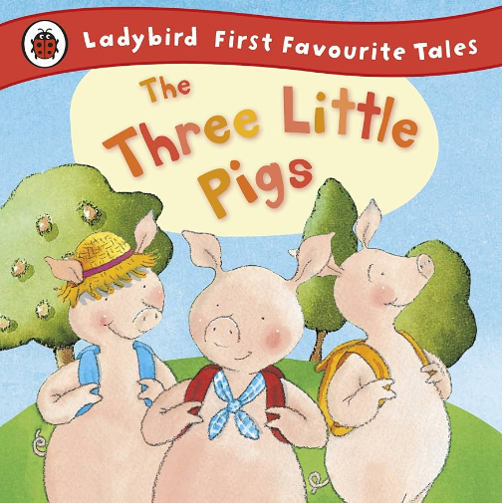

This half term we will be:

* Counting out objects from a larger set
* Ordering and writing numbers,
* Learning about size and shape,
* Using the maths area to practise our counting skills.

This half term we will be:

* Acting out different stories together,
* Using the story language in traditional tales,
* Talking about seasonal changes
* Learning to use words to communicate with each other

**Learning Letter Spring 1 EYFS**

Traditional Tales

This half term we will be:

* Crafts connected to our story books,
* Having gym lessons in the hall,
* Learning how to use different materials to create pictures,
* Learning new songs and rhymes,

This half term we will be:

* Discussing our classroom rules and why we have them,
* Looking at the different characters in the story and how they are feeling,
* Thinking about how to live a healthy lifestyle.

This half term we will be:

* Using our phonics knowledge to discriminate sounds and identify rhymes.
* Retelling stories,
* Talking about how we made porridge and what it tastes like,
* Mark making with writing equipment and recognising/writing our names.

This half term we will be:

* Manipulating playdough to represent things,
* Learn how to control our bodies and use them in different ways in our outside area.

**EYFS Half Term Learning Project**

**How many Traditional Tales can you read at home? Which is your favourite Traditional Tale? Why is this your favourite? Can you create some artwork in response to this story?**