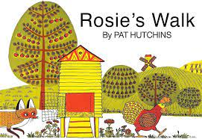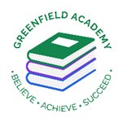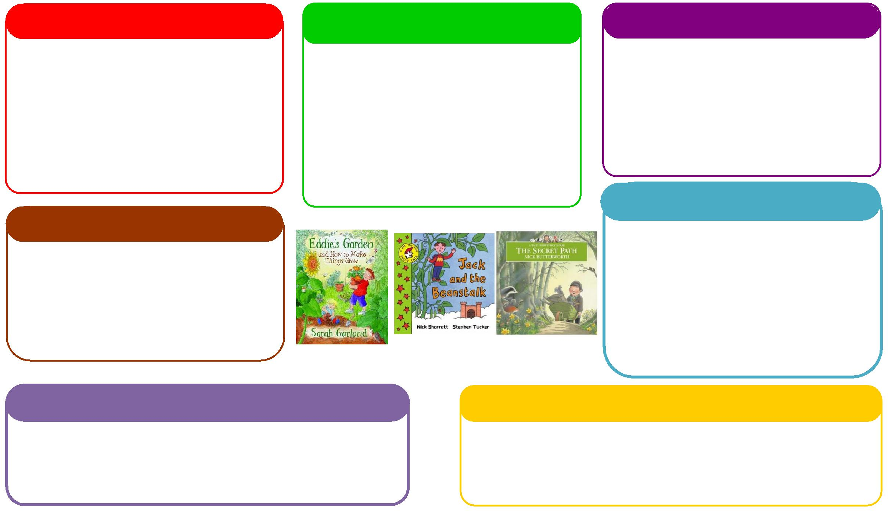

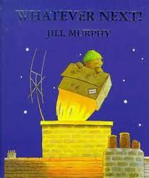vvv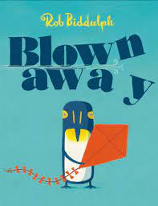

This half term we will be:

* Learning about the difference between farms and cities
* Learning about Space and going on a Space Picnic (All parents are invited to this event).
* Learning about different countries.

**Expressive Arts and Design**

**Personal, Social and Emotional Development**

**Understanding the World**

**Physical**

**Mathematics**

**Communication and Language**

**English**

This half term we will be:

* Counting out objects from a larger set
* Ordering and writing numbers,
* Learning about positional language,
* Learning how to sequence things.

This half term we will be:

* Acting out different stories together,
* Learning new words about farms, space and hot and cold places,
* Talking about seasonal changes
* Learning to use words to communicate with each other

**Learning Letter Spring 2 Nursery**

Journeys and Transport

This half term we will be:

* Making farm animals in different ways,
* Making Space Rockets,
* Exploring colour mixing to represent hot and cold.

This half term we will be:

* Discussing how to keep safe when going on a journey,
* Looking at healthy foods
* Talking about respecting other cultures.

This half term we will be:

* Using our phonics knowledge to begin to hear letters at the beginning of words.
* Retelling stories – Rosie’s Walk, Whatever Next, Blown Away
* Writing invitations for our Space Picnic
* Beginning to write our names and some letters.

This half term we will be:

* Learning how to wash & dry our hands, going to the toilet and putting our coats on independently,
* PE sessions in the hall.
* Learn how to take part in team activities.

**EYFS Half Term Learning Project**

**We are learning about Journeys and Transport this half term.**

**Please can you bring in something that your child can show about a journey they have been on.**

**You could even do some art and craft about their journey.**

**We will display their work in school so everyone can admire it.**