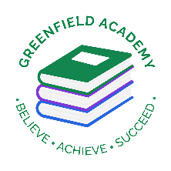**Greenfield Primary Academy**

**Year 3**

**Spring Term 2 Learning Letter 2024**

**In Maths we are learning to …**

In Maths, we will be exploring numbers up to 4 digits and addition and subtraction, and we will be:

- Read, write and compare numbers

- Word problems

- Multiply by 10 and 100

- Missing factors

- Inverse operations

- Dividing by 10 and 100

- Missing factors

- Adding and subtracting fractions

- Equivalent fractions

- Making and reading the time digitally

- Roman numerals

**In English we are learning to …**

**Write in different ways:** Stories from another culture, informal letter and non-chronological report.

**Read more fluently:** this term we will continue with whole class comprehension lessons. Your child will have a reading book and will also have access to MyOn – our online reading program.

**Understand Grammar:** Suffixes, Past tense, Present perfect form of verbs, Homographs, Determiners

**In Art and Design we are learning…Food**

**- Food** Seasonal tart (Baking)

Understand how to prepare and cook a savoury dish safely and hygienically including, where appropriate, the use of a heat source.

Begin to understand how to use a range of techniques such as peeling, chopping, slicing, grating, mixing, spreading, kneading and baking

**- Form and Sculpture** (Paper technology)

-

**In RE we will explore the questions …** Why are festivals important to religious communities?

- Make connections between stories, symbols and beliefs with what happens in at least two festivals.

- Ask questions and give ideas about what matters most to believers in festivals.

- Identify similarities and differences in the way festivals are celebrated within and between religions.

- Explore and suggest ideas about what is worth celebrating and remembering in religious communities and in their own lives.

**Our Learning Theme is …**

**In History we are learning to … Mayan Civilisation**

**-** To understand that the Mayan civilization started in 2000BC and ended in 250AD.

- Know about the impact that the Mayan civilisation had on the world.

- Know why they were considered an advanced civilisation in relation to that period of time in Europe

​

**In Science we are learning…**

-identify and describe the functions of different parts of flowering plants: roots, stem/trunk, leaves and flowers

- explore the requirements of plants for life and growth (air, light, water, nutrients from soil, and room to grow) and how they vary from plant to plant

-investigate the way in which water is transported within plants

-explore the part that flowers play in the life cycle of flowering plants, including pollination, seed formation and seed dispersal.

**In RHE/ PSHE we are learning to …**

Identify some of the dangers of being online

Understand the importance of keeping personal information safe

Describe how to behave appropriately online

**READING**

Please share your child’s reading book with them, as **10-15 minutes** of reading **every day** at home can make a lot of difference to your child's reading ability.

Your child MUST bring their book bag into school **every day** so an adult can read with them on their reading day, and any extra days if there is an opportunity.

Each child will have a reading book, and an extra book from the class library.

**MATHS**

Each child has received a copy of multiplications to 12. Please use this to work with your child so they become more confident with their times table knowledge.

**PURPLE MASH**

Each week the children will be set several tasks on Purple Mash. They log on to their account and complete their tasks. When they log on, there is a bell at the top of the screen. When they click on this, it will show them all the tasks they need to complete for that week.

Tasks are allocated on a Friday and have to be completed by the following Tuesday. There is usually a grammar, writing, spelling, maths and a Topic task.

**Swimming**

The children will continue to go swimming weekly.

**Year 3 Half Term Learning Project**

**Year 3 Weekly Home Learning Tasks**

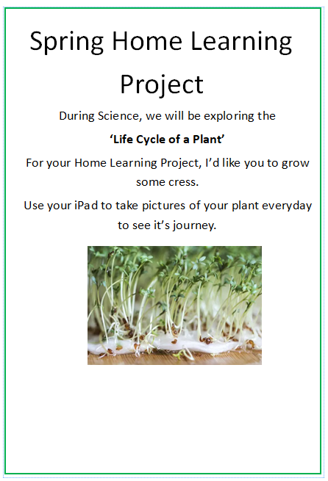

Due back on

**Friday 28th March**

Keep the cress at home, maybe eat it.

Take pictures of it every day.