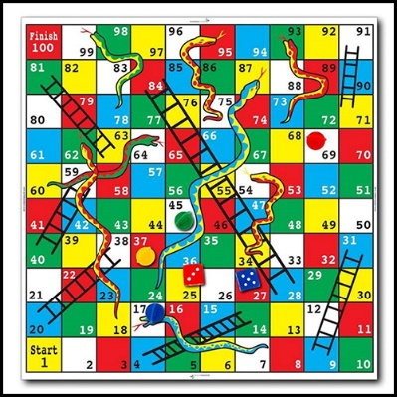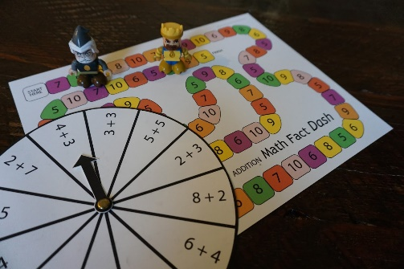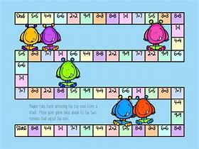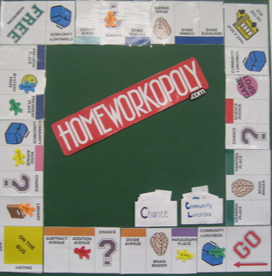

Home Learning Project Autumn 2

**Design a Maths board game**

Must include:

* A board

* Counters

* Set of instructions

* Extra cards (if needed)

Be creative!

Due back on the **Monday 22th November**