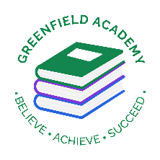**Greenfield Primary Academy**

**Year 1**

**Autumn Term Learning Letter 2021**

**In Maths we will continue our addition and subtraction strategies and begin to learn how to subtract from 10.**

**We will develop our knowledge of the properties of shapes and learn about 2d and 3d shapes.**

**We will begin to learn about place value up to 20, learning to order, recognise and count up to 20.**

**In English we are learning to write a character description based on a monster from our book ‘The Monster Machine’. We will also write monster poems. We will develop our knowledge of adjectives and build great descriptive sentences. We will read ‘The Dragon Machine’ and write instructions for how to make our own. We will use time connectives and our best punctuation. We will also write information about Alexander Bell who invented the telephone using our best conjunctions.**

**Our Learning Theme is …**

**‘Inventors and Inventions’**

**In RE we will continue to learn all about the Muslim faith.**

**We will make mosque models.**

**We will hear stories from the Quran and consider what Muslim people learn from them.**

**In DT we are learning to prepare, chop, slice and serve food as we make a fruit salad for a vegetarian monster.**

**We will explore and taste fruit, prepare it and evaluate our finished products.**

**In Science we will learn all about seasonal changes.**

**We will concentrate on naming the four seasons and learn what order they occur in.**

**We will describe weather associated with each season, compare and interpret weather data and consider how humans and animals adapt to changes in weather.**

**In History we will be learning all about the history of communication. We will start by looking at ancient hieroglyphics and creating our own sand paper art.**

**We will be learn all about the inventors of the telephone, the world wide web and the printing press and how they changed the world for the better.**

**In RHE/ PSHE we are learning to understand why relationships are important. We will consider how to make friends, keep our friends and make new friends. We will act out friendship scenarios and consider if we could handle conflict differently.**

**READING**

Please share your child’s reading book with them, as **10-15 minutes** of reading **every day** at home can make a lot of difference to your child's reading ability.

Your child MUST bring their book bag into school **every day** so an adult can read with them on their reading day, and any extra days if there is an opportunity.

Please complete your reading book and comprehension questions on Phonics Bug each week which can be found in your Phonics Bug library.

**MATHS**

**Please support your child to recognise and count numbers to 20, counting forwards and backwards. Look at different shapes in the environment and name and describe any shapes around the home.**

**PURPLE MASH**

**Please complete your weekly Maths and Writing tasks set.**

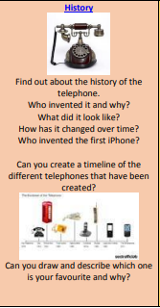

**Year 1 Half Term Learning Project**

**Year 1 Weekly Home Learning Tasks**