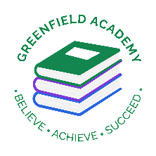**Greenfield Primary Academy**

**Year 3**

**Summer Term 1 Learning Letter 2025**

**In Maths we are learning to …**

In Maths, we will be exploring numbers up to 4 digits

- Finding missing numbers on a number line with marked intervals

- Placing numbers on a number line

- Estimating the value of intervals on a number line

- Problem solving with number lines

- Column addition and subtraction

- Giving change practically (shopkeeper method)

- Giving change on a number line

- Name and describe the properties of 3d shapes

- Sort 3D shapes

- Measure mass

- Compare mass

- Add and subtract mass

**In English we are learning to …**

**Write in different ways:** Myths and Legends, Instructions and poetry appreciation.

**Read more fluently:** this term we will continue with whole class comprehension lessons. Your child will have a reading book and will also have access to MyOn – our online reading program.

**In RE, we will explore the questions …** What do different people believe about God?

- Describe some of the ways in which Christians, Hindus and Muslims describe God.

- Ask questions and suggest some of their own responses to ideas about God.

- Suggest why having a faith or belief in something can be hard.

- Identify how and say why it makes a difference in people’s lives to believe in God.

**In Art and Design, we are learning…Egyptian Printing**

**-** To print using different techniques e.g. block, relief and impressed.

- To record different textures and patterns.

- To colour mix through overlapping colour prints.

**Our Learning Theme is …**

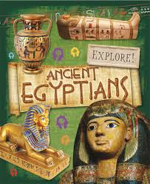

**In History, we are learning…**Ancient Egypt

- To know when the Ancient Egyptian civilization began in 3100 B.C. and ended in 332 B.C.

- Know about, and name, some of the advanced societies that were in the world around 3000 years ago

- Understand what life was like in Ancient Egypt.

-

​

**In Science we are learning… Nutrition and Diet**

- To know there are 6 main food groups animals need to stay healthy.

- To know which foods are rich in which nutrients.

- To understand the importance of each nutrient.

**In RHE/ PSHE we are learning… Similarities and Differences**

**The children will:**

- respect similarities and differences between people

- know what a healthy family life looks like

- know that other families look different to mine, but they are still based on love and care

- know that marriage is a recognised commitment and is meant to be lifelong

- know stereotypes including gender stereotypes can be destructive and unfair

**Year 3 Weekly Home Learning Tasks**

**READING**

Please share your child’s reading book with them, as **10-15 minutes** of reading **every day** at home can make a lot of difference to your child's reading ability.

Your child MUST bring their book bag into school **every day** so an adult can read with them on their reading day, and any extra days if there is an opportunity.

Each child will have a reading book, and an extra book from the class library.

They all now have access to MyON – the schools online reading app so as to help develop and improve their reading.

**MATHS**

Each child has received a copy of multiplications to 12. Please use this to work with your child so they become more confident with their times table knowledge.

**Swimming/P.E**

The children will continue to go swimming weekly on Tuesday and P.E will be on Fridays.

**Year 3 Half Term Learning Project**

Due back 15th May