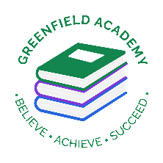**Greenfield Primary Academy**

**Year 1**

**Spring Term Learning Letter 2021**

**In Maths we will continue to learn how to add and subtract numbers up to 20. We will learn about the value of numbers up to 50 and begin to count up to and from 50. We will continue our work on one more and one less up to 50 and order numbers within 50. We will also learn how to count in 2’s and 5’s.**

**In English we are learning to write a character description based on the book ‘Meerkat Mail’. We will use our best handwriting to describe him. We will retell using adjectives, time connectives and conjunctions and work hard on our spelling strategies. We will also write a setting description based on the book ‘Lila and the Secret of the Rain’. We will finish by writing a poem called ‘Rumble in the Jungle’.**

**Our Learning Theme is …**

**‘Africa’**

**In RE we will be learning about the Jewish faith.**

**We will make mezuzahs and understand what religious artefacts are important in the Jewish faith.**

**We will hear the story of Hanukah.**

**In Art we will perfect our sculpture skills.**

**We will be making an African mask out of plasticine, using our own designs.**

**We will research other artists designs to give us ideas and plan the process out.**

**In Science we will learn all about materials.**

**We will be naming objects and labelling the materials they are made of. We will learn new vocabulary to help us describe the properties of materials and investigate their properties in lots of ways. We will test which materials are waterproof or absorbent and begin to think about how we can test fairly.**

**In Geography we will be learning all about the continent ‘Africa’. We will start by locating and naming the 7 continents of the world.**

**We will be learn all about Kenya and study the culture, climate, animals and facts about it. We will label maps and write sentences to record what we have learnt.**

**In RHE/ PSHE we will be learning about Communities. We will learn that we belong to different communities as well as our families. We will learn what it means to belong and our role within that family or community. We will also learn that it is everyone’s responsibility to look after our community**.

**READING**

Please share your child’s reading book with them, as **10-15 minutes** of reading **every day** at home can make a lot of difference to your child's reading ability.

Your child MUST bring their book bag into school **every day** so an adult can read with them on their reading day, and any extra days if there is an opportunity.

Please complete your reading book and comprehension questions on Phonics Bug each week which can be found in your Phonics Bug library.

**MATHS**

**Practice counting forwards and backwards to 50. Start counting in 2’s and 5’s.**

**PURPLE MASH**

**Please complete your weekly Maths and Writing tasks set.**

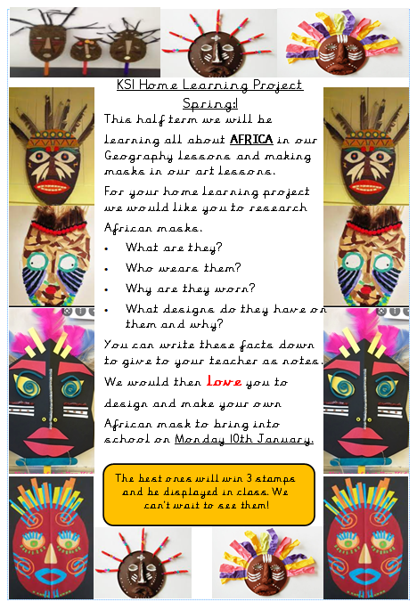

**Year 1 Half Term Learning Project**

**Year 1 Weekly Home Learning Tasks**