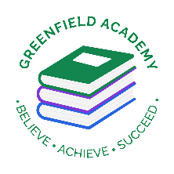**Greenfield Primary Academy**

**Year 1**

**Spring Term Learning Letter 2022**

**In Maths we will learn about weight and mass. We will measure weight and mass and compare the amounts. We will begin to understand volume and capacity and explore different ways to compare and measure capacity and volume.**

**We will also consolidate our learning in place value up to 50. We will compare, order and representing numbers to 50.**

**In English we are learning to write a character description and a story based on the book ‘The Great Explorer’. We use our best sentence skills to write information about the famous explorer ‘Christopher Columbus’ using some of our cross curricular vocabulary from our history lessons.**

**We will finish by reading ‘The Darkest Dark’ and writing a letter in role as the main character.**

**Our Learning Theme is …**

**‘Explorers’**

**In RE we will be learning all how and why we celebrate special and sacred times.**

**We will see how they are celebrated in each religion and we will discuss and compare them.**

**In DT we will study mechanisms.**

**We will discover how wheels and axles work by looking at existing products.**

**We will use our knowledge to design and make our own space buggy with moving parts.**

**In Science we will continue to learn all about materials.**

**We will be studying the changes on materials when they are subject to extreme heat or cold. We will turn water into ice and melt wax in our investigations whilst using our maths measuring skills.**

**In History we will be learning all two significant explorers and how their actions changed the world. We will start by finding out who Christopher Columbus was and what he set out achieve. We will then compare his achievements to Neil Armstrong’s and find out what the world was like in the 1960’s.**

**We will be learn all about the Apollo 11 mission and consider how the astronauts might have felt.**

**In RHE/ PSHE we will continue to learn with Zippy and his friends. We will learn all about conflict and resolution. We will think about times when we disagree and how we can solve disagreements together using a range of strategies.**

**READING**

Please share your child’s reading book with them, as **10-15 minutes** of reading **every day** at home can make a lot of difference to your child's reading ability.

Your child MUST bring their book bag into school **every day** so an adult can read with them on their reading day, and any extra days if there is an opportunity.

Please complete your reading book and comprehension questions on Phonics Bug each week which can be found in your Phonics Bug library.

**MATHS**

**Practice counting in 2, 5 and 10’s. Look at the weight and capacity of everyday objects using key vocabulary heavier/lighter and full/empty. Remember to complete Numbots each week.**

**PURPLE MASH**

**Please complete your weekly Maths and Writing tasks set.**

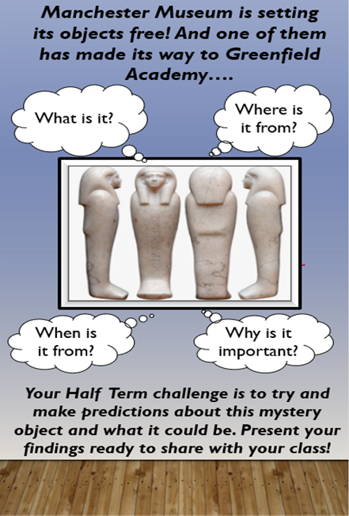

**Year 1 Half Term Learning Project**

**Year 1 Weekly Home Learning Tasks**