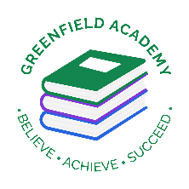**Greenfield Primary Academy**

**Year 6**

**Autumn Term Learning Letter 2021**

**In English we are studying Shakespeare where we will:**

**write plays and act out scenes.**

**Retell stories in our own way.**

**Write diaries and biographies as well as character profiles.**

**In Maths we are learning:**

* **Place Value to 10 million including comparing and ordering numbers.**
* **How to round numbers and use negative numbers.**
* **How to use formal written methods to calculate the four operations - + x and ÷**

**Our Learning Theme is …**

**TUDORS**

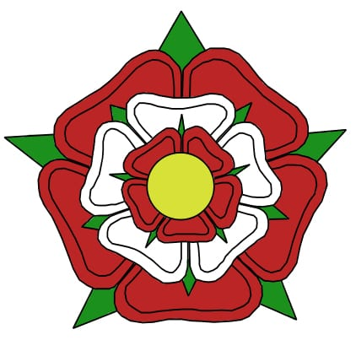

**In RE we are studying:**

* **What helps Muslims through the journey of life.**
* **What the key belief is for Muslims.**
* **How prayer matters.**
* **Why charity matters to Muslims.**

**In Art we are learning to:**

* **Make mini portraits based on Tudor people.**
* **Learn how to draw portraits**
* **Creating a miniature family tree of the Tudors.**

**In History we are learning about:**

* **The Tudors**
* **The Battle of Bosworth**
* **Tudor Monarch**
* **Henry VIII and his six wives**
* **Reformation**
* **Spanish Armada**

**In Science we are learning about:**

* **How light travels in straight lines.**
* **All surfaces reflect light**
* **How refraction changes direction of light**
* **How prisms create a ray of different lights**
* **Light enables us to see colours.**

**In RHE/ PSHE we are learning about:**

* **Rights and responsibilities, why manners, courtesy and respect are important.**
* **Democracy and voting as well as leaning that self-respect is important to our own happiness.**
* **How to respect others and treat them how we expect to be treated**

This half term we are learning about The Tudors.

Whilst we are focusing on the monarchy and changes during class time, we would like you to create a project on Tudor life.

You may choose to focus on housing, food or crime and punishment.

You could produce a model, fact book, research project or an amazing piece of artwork. We are looking forward to seeing how creative you can be.

Please ensure these are handed in to your class teacher by the **16th October**, ready for viewing in the final week. We are extremely excited to see what you can create and find out.

**Year 6 Half Term Learning Project**

**READING**

Please share your child’s reading book with them, as **10-15 minutes** of reading **every day** at home can make a lot of difference to your child's reading ability.

Your child MUST bring their book bag into school **every day** so an adult can read with them on their reading day, and any extra days if there is an opportunity.

They must also log in to MYON and read book and answer the questions 3x week.

**MATHS**

Children must continue to log in and use TTRockstars to practice their times tables and Sumdog to help support their maths learning

**Year 6 Weekly Home Learning Tasks**