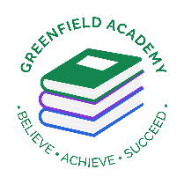

THE HARMONY TRUST

Greenfield Academy

Thursday 15th September

Dear Parents/Carers,

**Year 6 Class Assembly**

Sachar and Morpurgo will be performing a class assembly together about ‘Peace’.

We would like to invite two family members to attend the performance on Wednesday 21st September at 9:05am which will start promptly.

We hope you will come and support your child in their first Class Assembly to take place since COVID-19.

Thank you for your continued support,

Mrs Bawany and Mrs Ashton