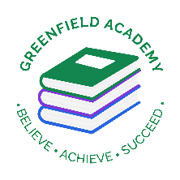**Greenfield Primary Academy**

**Year 6**

**Autumn Term 2 Learning Letter 2021**

**In English we are studying :**

**The Rainbow Crow:** Writing alternative ending and a setting description.

**The Christmas Carol by Charles Dickens**: write newspaper reports

**The Grinch:** performing it to class.

You can help by: Watching The Christmas Carol; reading The Grinch and reading different myths and legends genre books.

**In Maths we are learning:**

**Fractions**

* add and subtracting fractions.
* Multiplying and dividing fractions
* Simplifying
* Fractions of amounts
* Ordering and comparing

**Geometry – Position**

* Coordinates.

**Our Learning Theme is …**

**TUDORS**

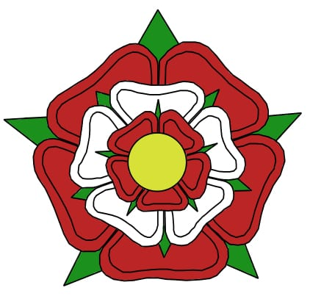

**In RE we are studying:**

* What is Racism and what we learn from different religions?
* What can we learn from the statues in Bristol?
* How Saint Peter learnt God had no favourites?
* What the Golden rule is and why it is found in different religions?

**In D.T we are learning to:**

**Make Brooches**

* Research and design their brooch.
* Stitching using different techniques
* Deciding on suitable material
* Make their brooch.

**In Geography we are learning about: Americas**

* Identify North America countries.
* Compare climates and understand weather patterns.
* Investigate geographical and human features.
* Explore time zones and capital cities in North America.
* Compare to UK.

**In Science we are learning about: Evolution, Inheritance and Adaptation**

* How living things change over time.
* How fossils provide information about life millions of years ago on Earth.
* How plants and animals adapt to their environment.
* How genetic inheritance occurs.

**In RHE/ PSHE we are learning about Feelings and Communication from Apple Programme.**

* Coping strategies for dealing with feelings in difficult situations.
* Coping strategies for communicating in different situations.

Next half term we will be studying Evolution, Inheritance and Adaptation in Science.

For your project we would like you to ***Design your own species.*** You can choose where they live from the habitats below and then think about what adaptations they need in order to survive there. For example, polar bears have large paws with retractable claws to help them dig into snow in their icy habitats.

**Habitats: Polar, Desert, Rainforest, High altitude, Deep Sea and Rocky Shore**.

Think about what the habitat’s climate is like (we can give you information to help with this), then think about the animals you know you would find there and what features they have to help them survive.

You can either create a 3D model of your species or a drawing. You must have information about the species you have created, for example, its name and features to help it survive.

**Year 6 Half Term Learning Project**

In Year 6 there is a certain expectation when it comes to Home Learning. Please see this outlined below:

**MyOn**

Children are expected to complete MyOn reading everyday as well as reading their reading book.

**TT Rockstars**

Children will be set 25mins (5 mins daily) of TTRockstars to practise their times tables.

**SumDog**

Children will be set a task on SumDog where they have 50 questions to answer based on their learning in class that week.

**Mental Arithmetic**

Children be given a mental arithmetic test every other week to complete.

**Home Learning is set on a Friday and is expected to be completed by Tuesday morning.**

**Year 6 Weekly Home Learning Tasks**