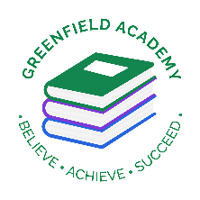**Greenfield Primary Academy**

**Year 5**

**Autumn Term 2 Learning Letter 2022**

**In Maths we are learning:**

**Multiplication and Division**

* Multiples/Factors/Common Factors
* Prime Numbers/Squared Numbers/Cube Numbers
* Multiplying by 10, 100 and 1000
* Dividing by 10, 100 and 1000
* Multiples of 10, 100 and 1000.

**Area and Perimeter**

* Measuring and Calculating Perimeter
* Area or Compound and Irregular Shapes.

**In English we are studying:**

* **The Rainbow Crow:** Writing alternative ending and a setting description.
* **The Christmas Carol by Charles Dickens**: write newspaper reports
* **The Grinch:** performing it to class.

You can help by: Watching The Christmas Carol; reading The Grinch and reading different myths and legends genre books.

**Our Learning Theme is …**

**TUDORS**

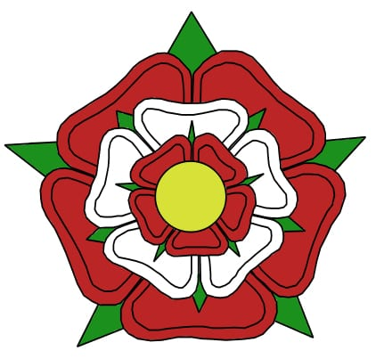

**In RE our question is:**

What does it mean to be a Muslim in Britain today?

**We will be studying:**

* What helps you through the journey of life?
* What is the key belief of Muslims?
* What are the 5 Pillars of Islam and why are they important?
* Where do people get advice and guidance from?

**In D.T we are learning to:**

**Make Brooches**

* Research and design their brooch.
* Create mock ups and templates to help with designing
* Stitching using different techniques
* Deciding on suitable material
* Make their brooch.

**In Science we are learning about: Earth and Space**

* The size of the Earth, Moon and Sun
* Creating solar system representations
* How shadows change throughout the day
* The Earths movement through different time zones
* Different phases of the moon
* Presenting their findings in different ways

**In Geography we are learning about: Americas**

* Identify North America countries.
* Compare climates and understand weather patterns.
* Investigate geographical and human features.
* Explore time zones and capital cities in North America.
* Compare to UK.

**In RHE/PSHE we are learning about: Nutrition and Food**

* How to make informed decisions about health
* The elements of a balanced, healthy lifestyle
* Choices that support a healthy lifestyle, and recognise what might influence these
* What good physical health means; how to recognise early signs of physical illness
* How regular (daily/weekly) exercise and getting enough sleep benefits mental and physical health
* How medicines, when used responsibly, contribute to health and some diseases can be prevented by vaccinations.

In Year 5 there is a certain expectation when it comes to Home Learning. Please see this outlined below:

**Individual Reading Books**

All children must read a few pages each night at home and write a comment in their reading diary.

**MyOn**

Children are expected to complete MyOn reading everyday with books of their choice online.

**TT Rockstars**

Children will be set 25mins (5 mins daily) of TTRockstars to practise their times tables.

**SumDog**

Children will be set a task on SumDog where they have 50 questions to answer based on their learning in class that week.

**Spellings**

Children will have spelling practise to complete based on those words they found tricky in the lesson that week and a spelling quiz on Purple Mash.

**Home Learning is set on a Friday and is expected to be completed by Monday morning.**

**Year 5 Weekly Home Learning Tasks**

**Year 5 Half Term Learning Project**

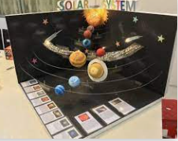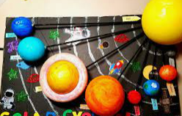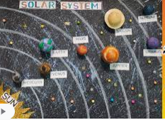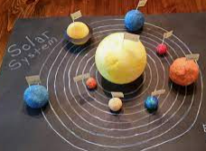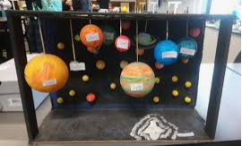

Next half term we will be learning about **Earth and Space** in **Science.**

We would like you to create a PowerPoint or a 3D model solar system and include the Sun, Moon and all the 8 different planets, along with some key information about our solar system. Think about the size and scale of your project if making the 3D model and where everything will be positioned. You can choose any materials you like to create it and it can be as big or small as you like but make it as WOW as you can!

Below are some examples of other children’s representation of The Solar System to give you some inspiration and help you think about how you are going to create yours at home.