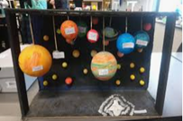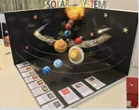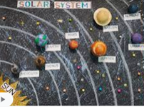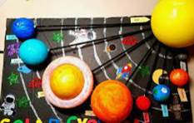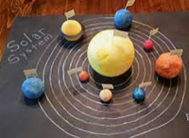

**Our Autumn 2 project is about - The Solar System**

This half term we are looking at Earth and Space. While we are looking at the effects of Space on Earth, we would like you to focus on the Solar System.

We would like you to research the 8 planets in the Solar System. You could find out about their moons, rings, colour, size etc. You can create a PowerPoint or make a solar system 3D model with notes about each planet. You can choose any materials you like to create it and it can be as big or small as you like but make it as WOW as you can! You could create a fact sheets about each planet. You can do this on your own or work with a partner.

Below are some examples of other children’s representation of The Solar System to give you some inspiration and help you think about how you are going to create yours at home.

This project is due in on **Monday 21st November 2022.**

We can’t wait to see your projects. Have fun!

**Mrs Greaves and Mrs Ahmed**